

**Diamond Price Analysis using Python**

***Project submitted to the***

***S K Somaiya College, Somaiya Vidyavihar University For the partial fulfilment for the award of the degree of* Bachelor of Data Science**

***Submitted By***

**Name of the Student: Tanvi V. Deodhar**

**Seat No. – 31013021001**

**T.Y.BSc Data Science Sem V**

**DEPARTMENT OF COMPUTER SCIENCE ACADEMIC YEAR 2023-2024**

***Under the Supervision of***

Faculty Name: Ms. Minal Dive

DEPARTMENT OF COMPUTER SCIENCE

**CERTIFICATE OF AUTHENTICATION**

This is to certify that this Project is a work of “*Tanvi Deodhar (31013021001)* submitted to the S K Somaiya College in partial fulfilment of the requirement for the award of the degree of Bachelor of Data Science

I consider that the project has reached the standards and fulfilling the requirements of the rules and regulations relating to the nature of the degree. The contents embodied in the project have not been submitted for the award of any other degree or diploma in this or any other university.

**Date: 29/11/2023**

**Place: S K Somaiya College, Somaiya Vidyavihar University, Mumbai.**

(Name and Signature)

Faculty Incharge – Ms. Minal Dive

(Name and Signature)

Coordinator:

**Declaration by the student**

**I certify that.**

a) The work contained in the thesis is original and has been done by myself under the supervision of my supervisor.

b) The work has not been submitted to any other Institute for any degree or diploma.

c) I have conformed to the norms and guidelines given in the Ethical Code of Conduct of the Institute.

d) Whenever I have used materials (data, theoretical analysis, and text) from other sources, I have given due credit to them by citing them in the text of the thesis and giving their details in the references.

e) Whenever I have quoted written materials from other sources and due credit is given to the sources by citing them.

f) From the plagiarism test, it is found that the similarity index of whole thesis is within 25%.

**Date: 29/11/2023**

**Place: S K Somaiya College, Somaiya Vidyavihar University, Mumbai.**

Signature

Tanvi Vinod Deodhar

31013021001

 

Department of Computer Science

CERTIFICATE

This is to certify that Ms. Tanvi Vinod Deodhar bearing seat no. 31013021001 of Bachelor of Data Science (Third year Sem V), has satisfactorily completed the Project titled Diamond Price Analysis in the partial fulfilment for the award of the Bachelor of Data Science degree by the Somaiya Vidyavihar University, during the Academic year 2022-23.

Signature of the Faculty Incharge Signature of the Coordinator

Signature of the Examiner Signature of the HOD

Date of Examination College Seal

**Acknowledgement**

I would like to express my sincere gratitude to everyone who contributed to the successful completion of my project work.

Their support, guidance, and encouragement have been invaluable throughout this journey.

First and foremost, I extend my heartfelt thanks to my supervisor, MS, Minal Dive and Ms. Swati Maurya for her unwavering support and mentorship. Their expertise, constructive feedback, and dedication played a pivotal role in shaping the direction of my project. I am truly grateful for their time and commitment.

I would like to acknowledge the DEPARMENT OF COMPUTER SCIENCE and its Head, Ms. Swati Maurya, for providing a conducive academic environment. The resources and facilities made available greatly facilitated my research work. My sincere appreciation goes to all faculty members who shared their knowledge and insights during the course of my study. THANK YOU.

Tanvi Vinod Deodhar

**Table of Contents**

**You may have subsections like given in Chapter 1 for every chapter**

|  |  |  |
| --- | --- | --- |
| **Sr. No.** | **Contents** | **Page No.** |
| **Chapter 1** | **Introduction**  **1.1 Introduction**  **1.2 Diamond Scams**  **1.3 Diamond Price Analysis**  **1.4 Scope of the Project** | 1 |
| **Chapter 2** | **Technology**  **2.1 Kaggle – about dataset**  **2.2 Python**  **2.3 Exploratory Data Analysis**  **2.4 Jupyter Notebook** | 10 |
| **Chapter 3** | **Project Work**  **3.1 Importing Libraries**  **3.2 Loading the Data**  **3.3 Exploratory Data Analysis**  **3.4 Data Preprocessing**  **3.5 Regressions**  **3.6 Final Output** | 19 |
| **Chapter 4** | **Screen Shots of Coding** | 44 |
| **Chapter 5** | **Conclusion** | 51 |
| **Chapter 6** | **Future Enhancement** | 52 |
| **Annexures** | **Bibliography** | 53 |
|  | **Web References** | 53 |

**Introduction**

A diamond is one of the most expensive stones. Diamond buyers often want to know which of the Four Cs of gem grading is most important — colour, clarity, cut, or carat. However, these qualities aren’t as distinct as they seem. Diamonds are weighed in carats, which are the standard measurement units. The term "size" is often used to misinterpret the meaning of diamond carat, which is actually a measurement of a diamond's weight. A diamond's carat weight is a measure of its size expressed as a percentage. Furthermore, one carat (1ct) of diamonds weighs about 0.20 grams (200 Milligrams).

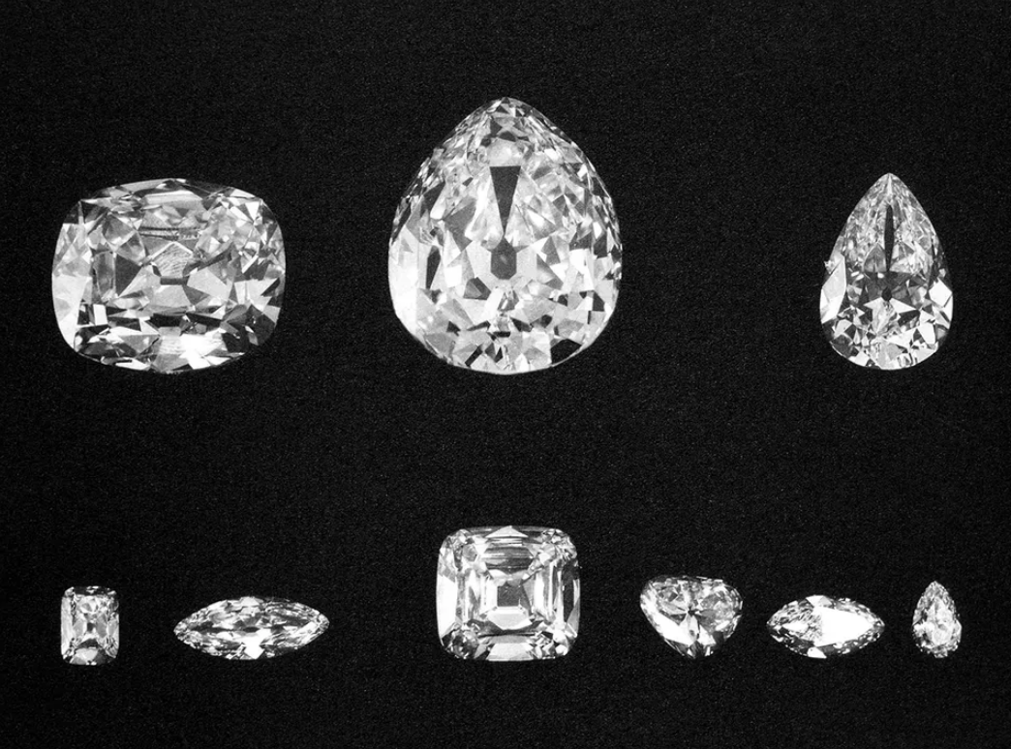

[Diamond](https://en.wikipedia.org/wiki/Diamond) is a solid form of the element carbon with its atoms arranged in a crystal structure called diamond cubic. At room temperature and pressure, another solid form of carbon known as graphite is the chemically stable form, but diamond almost never converts to it. Diamond has the highest hardness and thermal conductivity of any natural material, properties that are utilized in major industrial applications such as cutting and polishing tools. They are also the reason that diamond anvil cells can subject materials to pressures found deep in the Earth. For example, the finest diamonds received designations such as "gems of the first water." Lesser diamonds were known as diamonds of the "second" and "third water." When using these terms, Arab traders most likely referred to a combination of clarity, brilliance, and colourlessness. The finest diamonds were supposed to be limpid, like water, and brilliant and lively, as if a river moved through the stone.

diamond colour scale with the letter "D," just to differentiate the GIA's grading scale from all previous ones. Although "D" doesn't traditionally have very marketable connotations, Shipley's classification system became the industry standard. The grade "D" became synonymous with top colourless diamonds. There are different types of diamonds, diamonds are the perfect data set for machine learning and price prediction.

There are about 30 or 40 variables associated with any diamond.

**Diamond Scams**

Diamond scams are becoming more frequent these days. Some fraudsters attempt to destroy this experience by selling counterfeit diamonds, altering its certificate and so on. Since diamonds are expensive purchases, such scams put the buyers under a lot of financial and mental strain.

Should this demotivate you from purchasing diamonds? No, rather, as a buyer you must educate yourself about the most common diamond scams, and take precautions so as to ensure a satisfying buying experience.

Have you ever seen “50-75% off” signs on jewellery stores or websites? You probably might have. As enticing as they may look, they’re a shrewd marketing technique to attract customers and make sales by tricking them into believing that they are getting a steal deal.

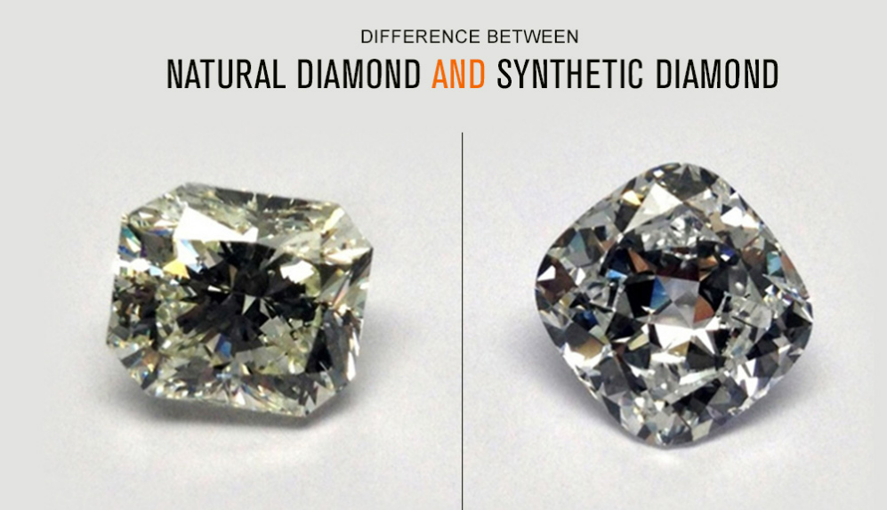

A certified diamond with I clarity and K colour is not a great diamond. Check the cut, colour, clarity and carat weight first. Just because it’s certified, doesn’t mean it’s good.

Hence, by using Python and Machine Learning Algorithm, I have created a model where we can predict the price of the carat by analysing the cut, colour, clarity, and its depth.

**Diamond Price Analysis**

To analyse the price of diamonds according to their attributes, we first need to have a dataset containing diamond prices based on their features

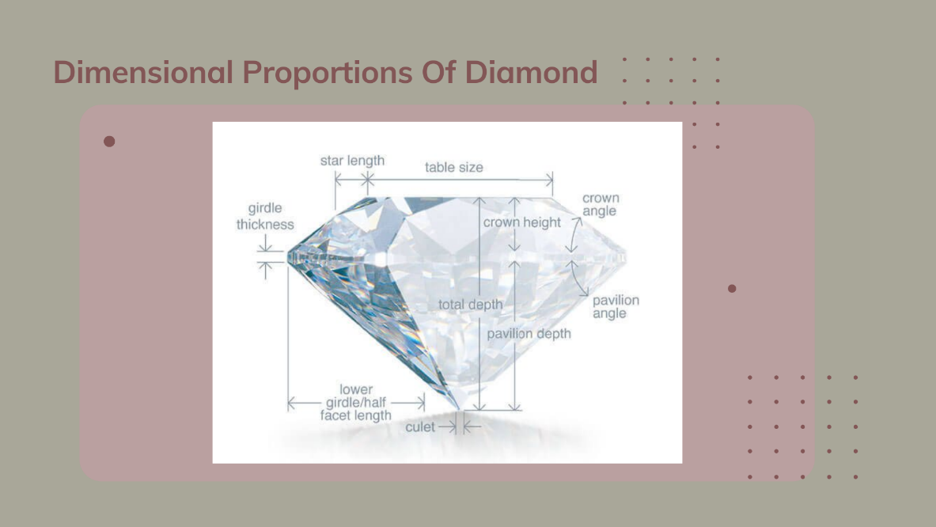

To predict the price of the diamond we need to first understand the Four Cs of gem grading is most important — colour, clarity, cut, or carat. It is used to interpret the reality of the diamond and how pure it is. Not only this, but the Four Cs determines the value of the diamond as well, which tells us the market price of the diamond.

Many a times we need to buy a good diamond but fall for some fraud or get cheated by the merchants. Hence, it is necessary to understand these terms.

* Carat

Carat is a unit of measurement used to quantify the weight of diamonds and other gemstones. One carat is equivalent to 200 milligrams, or 0.2 grams. The term "carat" is derived from the carob seeds that were historically used as counterweights on balance scales to measure gemstones. These seeds have a fairly uniform weight, making them suitable for such purposes.

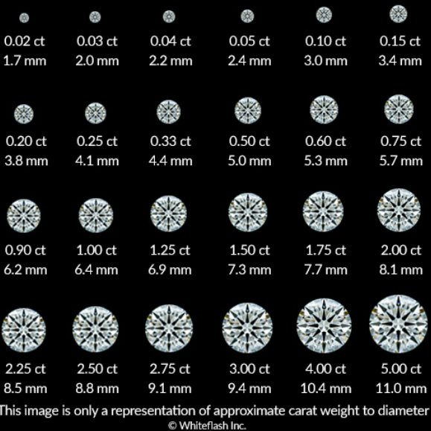

To put it simply, **diamond carat weight measures how much a diamond weighs.**

A metric “carat” is defined as 200 milligrams. Each carat is subdivided into 100 ‘points.’ This allows very precise measurements to the hundredth decimal place. A jeweller may describe the weight of a diamond below one carat by its ‘points’ alone. For instance, the jeweller may refer to a diamond that weighs 0.25 carats as a ‘twenty-five pointer.’ Diamond weights greater than one carat are expressed in carats and decimals. A 1.08 carat stone would be described as ‘one point oh eight carats.’

* Cut

The cut of a diamond refers to how well the diamond has been shaped and faceted, as well as the quality of the workmanship in creating the final polished diamond. The cut of a diamond is crucial because it directly affects the diamond's brilliance, sparkle, and overall visual appeal. A well-cut diamond reflects and refracts light in a way that maximizes its optical properties. The better the cut, the more the diamond will sparkle.

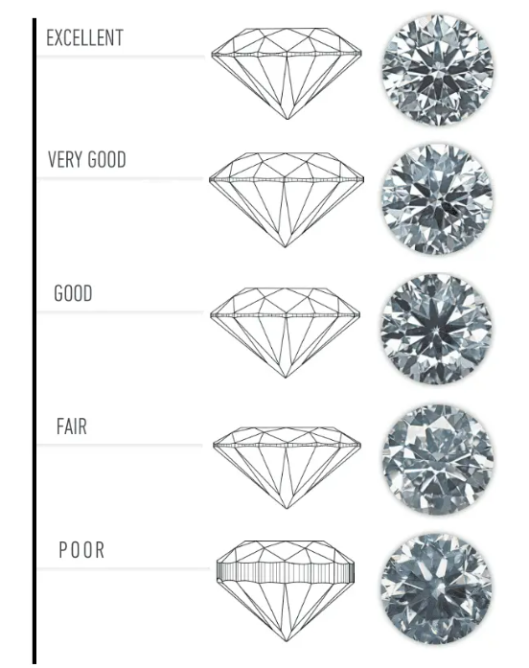

Well in this dataset which I have used is adapted from Kaggle hence, according to it (Ideal = Excellent) (Premium = Very Good)

(Very Good = Good) (Good = Fair) (Fair = Poor)

Diamonds with excellent or very good cuts are generally considered to have superior sparkle and brilliance. It's important to note that cut is different from the diamond shape (such as round, princess, emerald, etc.). The cut refers to how well the diamond's facets interact with light, regardless of its shape.

When selecting a diamond, it's often recommended to prioritize cut quality, as it has a significant impact on the overall beauty of the diamond. Even a diamond with high colour and clarity grades may appear less attractive if it is poorly cut.

* Clarity

Clarity is one of the Four Cs used to evaluate the quality of a diamond.

Clarity refers to the presence of internal and external flaws in a diamond, known as inclusions and blemishes, respectively.

Diamonds are formed deep within the Earth under extreme heat and pressure, and as a result, they often develop natural characteristics or imperfections. Inclusions are internal features, such as tiny crystals, clouds, or other imperfections, while blemishes are external flaws, like scratches or nicks on the diamond's surface.

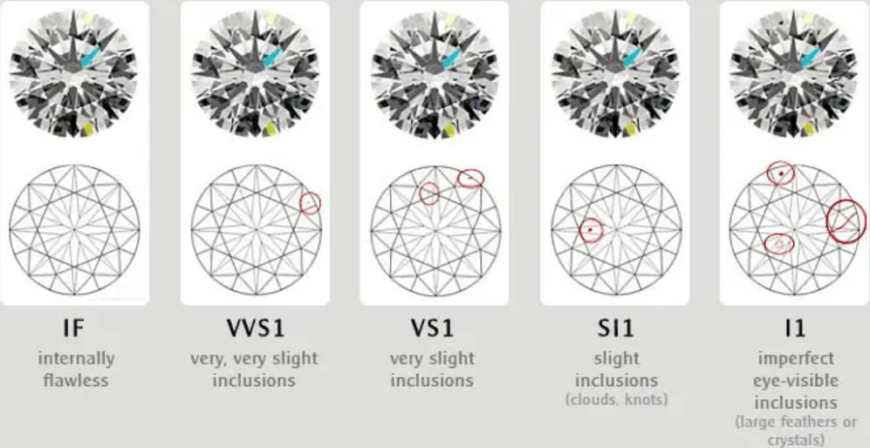

The Gemmological Institute of America (GIA) grades diamonds on a clarity scale that includes the following categories:

**Flawless (FL):** No inclusions or blemishes visible under 10x magnification.

**Internally Flawless (IF):** No inclusions visible under 10x magnification, but minor blemishes may be present.

**Very, Very Slightly Included (VVS1 and VVS2):** Inclusions are difficult to see under 10x magnification.

**Very Slightly Included (VS1 and VS2):** Inclusions are visible under 10x magnification but are considered minor.

**Slightly Included (SI1 and SI2):** Inclusions are noticeable under 10x magnification.

**Included (I1, I2, and I3):** Inclusions are visible to the naked eye and may affect the diamond's transparency and brilliance.

Generally, the higher the clarity grade, the more valuable the diamond. However, diamonds with slightly lower clarity grades can still be beautiful and may offer better value. When choosing a diamond, it's important to strike a balance between clarity and other factors, such as cut and colour, to find a diamond that meets your preferences and budget.

* Colour

Diamond color refers to the presence or absence of color in a white diamond, with the most valuable diamonds being those that are completely colorless.

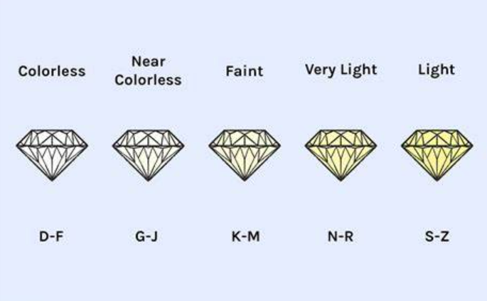

The Gemmological Institute of America (GIA) grades diamond colour on a scale that ranges from D (colourless) to Z (light yellow or brown). The scale is divided into the following categories:

**Colourless (D, E, F):** These diamonds are considered the most valuable because they are virtually devoid of any color.

**Near Colourless (G, H, I, J):** Diamonds in this range may have a slight hint of colour, but it is generally not noticeable to the untrained eye.

**Faint (K, L, M):** A faint colour may be visible to the naked eye, especially in larger diamonds.

**Very Light (N, O, P, Q, R):** The presence of colour is more apparent in these diamonds.

**Light (S, T, U, V, W, X, Y, Z):** Diamonds in this category have a noticeable amount of colour.

It's important to note that the colour scale is specific to white diamonds. Fancy colour diamonds, which exhibit colours other than shades of yellow and brown, are graded on a separate scale.

The choice of colour grade can be influenced by personal preferences and budget considerations. In many cases, diamonds in the near-colourless range (G to J) offer an excellent balance of quality and value.

* The depth, width and height

The depth, width, and height of a diamond are important dimensions that contribute to its overall appearance and characteristics.

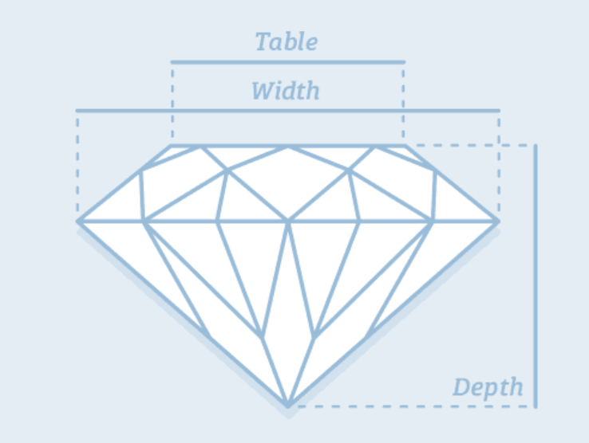

These measurements are often used in conjunction with the diamond's cut to determine its proportions. Let's explore each of these dimensions:

**Depth:** The depth of a diamond is the measurement from the table (the flat top surface of the diamond) to the culet (the pointed bottom). It is expressed as a percentage of the overall diameter of the diamond. The depth directly influences the brilliance and sparkle of the diamond. If the diamond is too shallow or too deep, it can affect how light is reflected within the diamond, impacting its overall beauty.

**Width:** The width of a diamond is often referred to as the diameter and is measured across the widest part of the diamond. This measurement is important in determining the diamond's size and how it will appear when set in jewellery.

**Height:** The height of a diamond is the measurement from the table to the culet, perpendicular to the depth. It is an additional dimension that, along with the depth and width, contributes to the overall shape of the diamond.

When considering these dimensions, it's crucial to look at the diamond's proportions, which include the relationships between these measurements. The balance of these proportions affects the diamond's ability to reflect light and create brilliance. Well-proportioned diamonds often exhibit superior sparkle and fire.

Diamond cutters aim to achieve ideal proportions to maximize a diamond's visual appeal. Proportion factors, such as table size, crown angle, and pavilion depth, are considered in the cutting process to create a diamond that is both visually stunning and structurally sound.

When shopping for diamonds, it's recommended to pay attention to the cut grade, as it takes into account factors related to the depth, width, and other proportions. A well-cut diamond is more likely to display exceptional brilliance and beauty.

So, the Four Cs are important for us to predict the value of the diamond. It is important for us to know how and when it can be used.

**Scope of this Project**

Analysing the price of diamonds can be a valuable and relevant project in today's world, considering the dynamic nature of the diamond industry and the factors influencing diamond prices. Here are some aspects to consider regarding the scope of a diamond price analysis project:

Market Dynamics:

Global Demand and Supply: Analyse the global demand and supply trends for diamonds. Factors such as economic conditions, consumer preferences, and changes in global jewellery markets can significantly impact diamond prices.

Mining Trends: Study the trends in diamond mining, including new discoveries, mining regulations, and technological advancements. Changes in mining practices can influence the availability and, consequently, the price of diamonds.

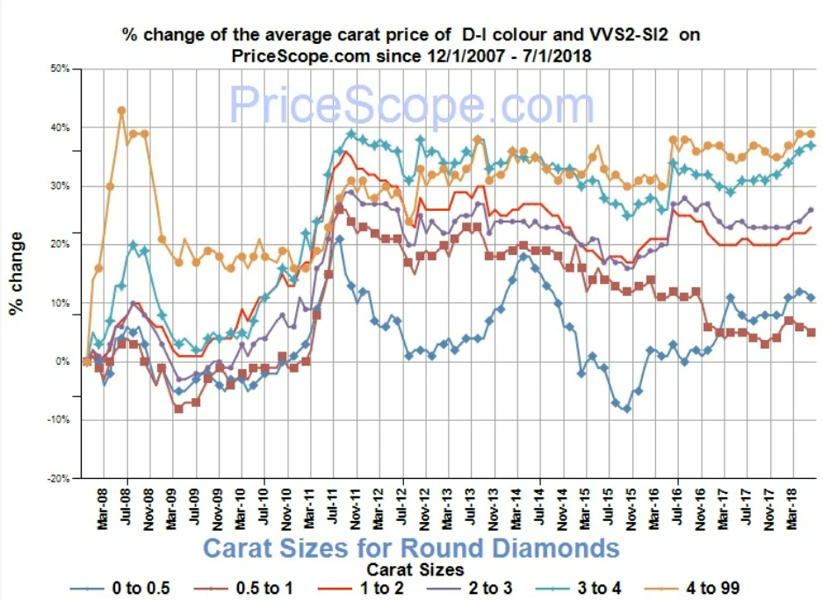

Economic Factors:

Macroeconomic Indicators: Consider macroeconomic indicators such as GDP growth, inflation rates, and currency exchange rates. Economic conditions can affect consumers' purchasing power and, in turn, demand for luxury items like diamonds.

Investment Trends: Examine the role of diamonds as an investment asset. Changes in investor sentiment, market speculation, and the overall economic climate can impact diamond prices.

Technological Advances:

Lab-Grown Diamonds: Assess the impact of advancements in diamond synthesis technology. The growing market for lab-grown diamonds can influence the pricing dynamics of both natural and synthetic diamonds.

Market Trends:

Consumer Preferences: Explore shifts in consumer preferences for diamond characteristics such as size, cut, colour, and clarity. Changes in fashion trends and consumer sentiment can influence demand and, consequently, prices.

Online vs. Offline Markets: Analyse the impact of e-commerce and online platforms on the diamond market. Changes in distribution channels and sales strategies can affect pricing structures.

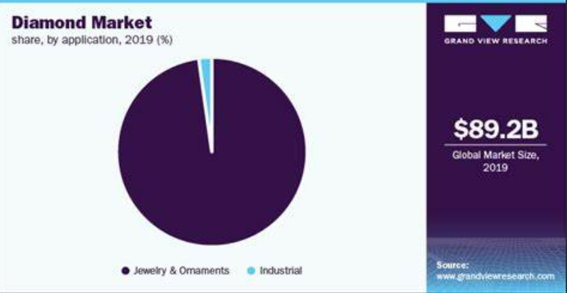

Regulatory Environment:

Environmental Regulations: Consider the impact of environmental regulations on diamond mining and processing. Compliance with ethical and environmental standards can influence production costs and, subsequently, diamond prices.

Data Analytics and Machine Learning:

Predictive Modelling: Use data analytics and machine learning techniques to build predictive models for diamond price movements. Analyse historical data to identify patterns and correlations that can help predict future price trends.

Risk Analysis:

Market Risks: Evaluate potential risks such as geopolitical instability, trade tensions, or natural disasters that could impact diamond prices. Develop risk management strategies for industry participants.

Sustainability and Ethical Considerations:

Ethical Sourcing: Investigate the impact of ethical sourcing practices on diamond prices. Consumer awareness and demand for ethically sourced diamonds can influence market dynamics.

Emerging Markets:

Asia-Pacific Region: Explore the growing influence of the Asia-Pacific region on the diamond market. Analyse trends in consumer behaviour and economic growth in key markets like China and India.

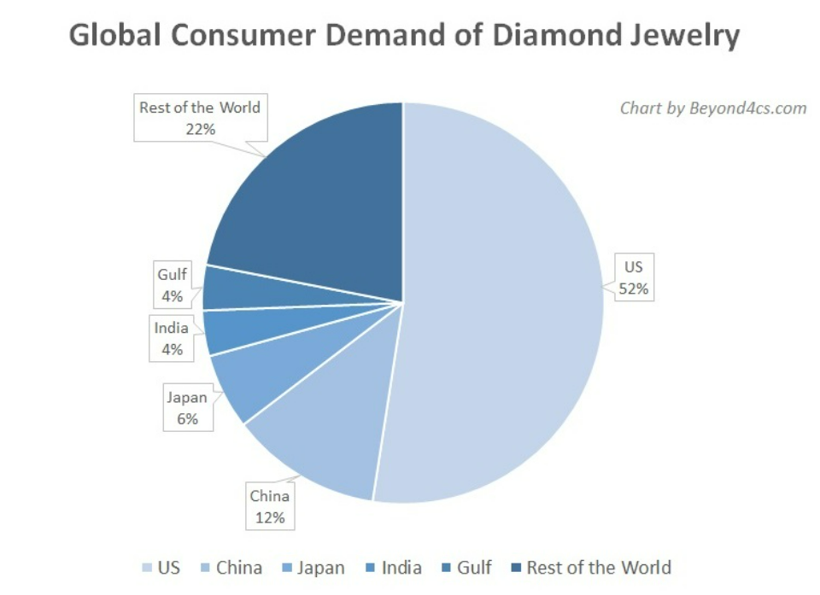

Scenario Analysis:

Black Swan Events: Consider the potential impact of unexpected events, such as global economic crises or breakthroughs in diamond synthesis technology, on diamond prices.

By considering these aspects, a comprehensive diamond price analysis project can provide valuable insights for industry stakeholders, investors, and policymakers in the ever-evolving diamond market

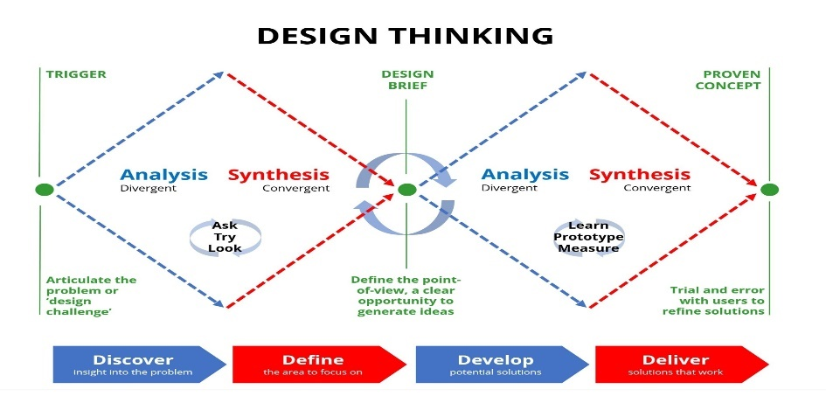

**Technology**

Several technologies and analytical approaches can be employed for diamond price analysis.

Well, we have used Python to form the analyse of Diamond price. We have used Kaggle for the ready-made data set.

**Kaggle**   
Kaggle is a platform for data science competitions, collaborative data science projects, and a community of data scientists and machine learning practitioners.

Kaggle hosts a variety of data science competitions where companies and organizations present real-world problems for participants to solve. These competitions often involve predictive modelling, machine learning, and statistical analysis. Kaggle offers a platform that caters to a wide range of needs in the data science and machine learning space.

The Dataset

This classic dataset contains the prices and other attributes of almost 54,000 diamonds. It's a great dataset for beginners learning to work with data analysis and visualization.

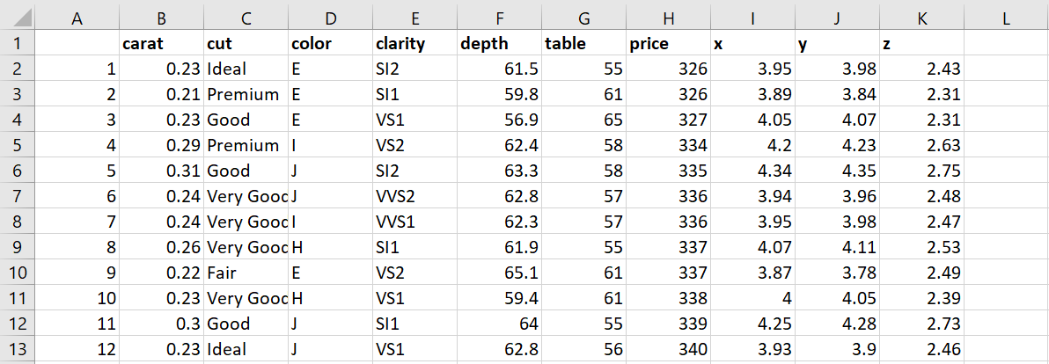

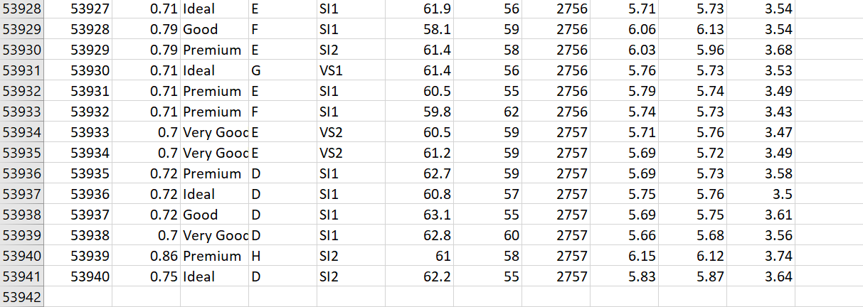

Feature description:

**price**price in US dollars ($326--$18,823)This is the target column containing tags for the features.

**The 4 Cs of Diamonds: -**

**carat (0.2--5.01)** The carat is the diamond’s physical weight measured in metric carats.  One carat equals 1/5 gram and is subdivided into 100 points. Carat weight is the most objective grade of the 4Cs.

**cut (Fair, Good, Very Good, Premium, Ideal)** In determining the quality of the cut, the diamond grader evaluates the cutter’s skill in the fashioning of the diamond. The more precise the diamond is cut, the more captivating the diamond is to the eye.

**colour, from J (worst) to D (best)** The colour of gem-quality diamonds occurs in many hues. In the range from colourless to light yellow or light brown. Colourless diamonds are the rarest. Other natural colours (blue, red, pink for example) are known as "fancy,” and their colour grading is different **than from white colourless diamonds.**

clarity (I1 (worst), SI2, SI1, VS2, VS1, VVS2, VVS1, IF (best))**Diamonds can have internal characteristics known as inclusions or external characteristics known as blemishes. Diamonds without inclusions or blemishes are rare; however, most characteristics can only be seen with magnification.**

Dimensions

x length in mm (0--10.74)

y width in mm (0--58.9)

z depth in mm (0--31.8)

depth total depth percentage = z / mean(x, y) = 2 * z / (x + y) (43--79)**The depth of the diamond is its height (in millimetres) measured from the culet (bottom tip) to the table (flat, top surface).**

**table width of the top of the diamond relative to widest point (43--95)**

A diamond's table refers to the flat facet of the diamond seen when the stone is face up. The main purpose of a diamond table is to refract entering light rays and allow reflected light rays from within the diamond to meet the observer’s eye. The ideal table cut diamond will give the diamond stunning fire and brilliance.

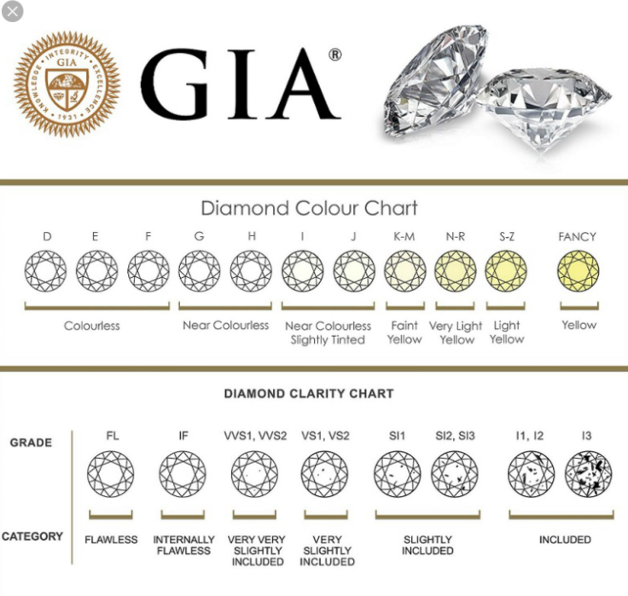

Tools:

**Python** an interpreted, object-oriented programming language with dynamic semantics. Its high level, built-in data structures, combined with dynamic binding, make it very attractive for rapid application development, also as to be used as a scripting or glue language to attach existing components together. Python and EDA are often used together to spot missing values in the data set, which is vital so you’ll decide the way to handle missing values for machine learning.

It was easy as well as helped me to learn more about this, Programming Language.

Python, as a programming language, has been developed with several overarching goals in mind. These goals help shape the language's design principles and influence the decisions made by the Python community. Some of the key goals of Python include:

**Readability:**

One of Python's most distinctive features is its emphasis on code readability. The syntax is designed to be clear and expressive, making it easy for developers to write and maintain code.

**Simplicity:**

Python strives for simplicity and minimalism in design. The language's syntax is designed to be straightforward, reducing the cost of program maintenance and development.

**Versatility:**

Python is a versatile language that supports multiple programming paradigms, including procedural, object-oriented, and functional programming. This versatility allows developers to choose the approach that best fits the problem at hand.

**Expressiveness:**

Python aims to allow developers to express concepts in fewer lines of code than might be possible in other languages. This makes the language more readable and reduces the likelihood of errors.

**Community and Collaboration:**

Python is developed and maintained by a large and active community. The community-driven development model encourages collaboration, open discussion, and sharing of knowledge. This collaborative spirit is reflected in the Python Enhancement Proposals (PEP) process, where proposals and changes to the language are discussed and decided upon.

**Portability**:

Python is designed to be highly portable, allowing code written in Python to run on various platforms without modification. This portability is facilitated by the availability of Python interpreters for different operating systems.

**Interoperability:**

Python is designed to be easily integrable with other languages and systems. It can be embedded in applications written in languages like C and C++, and it has interfaces to many external libraries.

**Consistency:**

Python emphasizes a consistent and uniform syntax, which makes it easier for developers to learn and work with the language. This consistency extends to naming conventions and coding style, as outlined in the PEP 8 style guide.

**Open Source and Free:**

Python is an open-source programming language, and its interpreter implementation, CPython, is freely available. This openness and accessibility have contributed to Python's widespread adoption.

**Large Standard Library:**

Python comes with a comprehensive standard library that provides modules and packages covering a wide range of functionalities. This "batteries included" philosophy means that many common tasks can be accomplished without needing to install third-party libraries.

**Security:**

Python is designed with security in mind, incorporating features like automatic memory management to reduce the risk of common programming errors leading to security vulnerabilities.

**Growth and Evolution:**

Python is continuously evolving. The community actively works on enhancing the language, adding new features, and improving performance. This commitment to growth ensures that Python remains relevant in the rapidly changing landscape of technology.

These goals collectively contribute to Python's popularity and success in a variety of domains, including web development, data science, machine learning, automation, and more.

*Why Python?*

Python is widely used in many projects and across various domains for several reasons. Python's syntax is clear, readable, and concise. Its design philosophy emphasizes code readability, which makes it easier for developers to write and maintain code. This readability contributes to reduced program maintenance costs and enhanced productivity. Python has a rich ecosystem of libraries and frameworks that cover a wide range of applications, from web development to data science, machine learning, and artificial intelligence. Popular libraries like NumPy, Pandas, TensorFlow, and Django simplify complex tasks and accelerate development. Python is widely used in data science and machine learning due to its extensive libraries like NumPy, Pandas, Scikit-learn, and TensorFlow. The language's simplicity and the availability of these libraries have contributed to Python's dominance in the field. Due to these factors, Python has become a go-to language for a wide range of projects, from small scripts and automation tasks to large-scale web applications, data science projects, and machine learning applications. Its versatility, readability, and extensive community support contribute to its popularity across various industries and domains.

***Exploratory Data Analysis (EDA) in Python***

Exploratory Data Analysis (EDA) is a critical step in the data analysis process where the main goal is to understand the main characteristics of the data set. EDA involves visually and statistically summarizing the key aspects of a data set to uncover patterns, relationships, anomalies, and insights. Explore the dimensions of the data (number of rows and columns). Identify the types of variables (categorical, numerical).

It an analysis approach that identifies general patterns in the data. These patterns include outliers and features of the data that might be unexpected. EDA is an important first step in any data analysis. An initial step in Exploratory Data Analysis (EDA) is to examine how the values of different variables are distributed. Graphical approaches for examining the distribution of the data include histograms, boxplots, cumulative distribution functions, and quantile-quantile (Q- Q) plots. Information on the distribution of values is often useful for selecting appropriate analyses and confirming whether assumptions underlying particular methods are supported (e.g., normally distributed residuals for a least square regression). EDA is a flexible process, and you may adapt these steps based on the specific characteristics and questions related to your dataset.

***Types of Graph you’ll see in EDA in this project used for regression and comparison:***

1. Scatter Plot

A scatter plot is a type of data visualization that displays individual data points on a two-dimensional graph. Each point on the graph represents the values of two variables. One variable is plotted on the x-axis, and the other variable is plotted on the y-axis. Scatter plots are useful for visualizing the relationship between two continuous variables and identifying patterns or trends in the data.

Each data point on the scatter plot represents a unique combination of values for the two variables.

Scatter plots help in identifying patterns, correlations, or trends in the data. For example, you can observe if there is a positive or negative correlation between the variables.

The clustering of points or the direction of the trend line can provide insights into the strength and direction of the correlation between the two variables.

1. Violin Plot

A violin plot is a data visualization that combines aspects of a box plot and a kernel density plot. It is particularly useful for displaying the distribution and density of a dataset across different categories or groups. The plot gets its name from its resemblance to a violin.

Violin plots are often used to compare the distribution of a continuous variable across different categories or groups.

The width of the plot at any given point represents the estimated probability density of the data. Wider sections indicate higher density.

box plots, violin plots also include elements such as median lines, quartiles, and whiskers, providing information about the central tendency and spread of the data.

The plot is usually symmetrical along the y-axis, making it easy to compare distributions between categories.

1. Heat Map

A heatmap is a data visualization technique that represents the magnitude of a phenomenon as color in two dimensions. It is a graphical representation of data where values in a matrix are represented as colours. The colours in a heatmap typically range from cool to warm, where cool colours represent lower values, and warm colours represent higher values.

Heatmaps are often used to visualize data in a matrix format, where rows and columns correspond to different variables or categories.

Colours are used to represent the values in the matrix, creating a visual representation of the data distribution. A gradient of colours, often from a cool color (e.g., blue) to a warm color (e.g., red), is used to convey variations in magnitude.

The intensity or darkness of a color in a heatmap represents the magnitude of the corresponding value. Darker colours indicate higher values, while lighter colours indicate lower values.

1. Pairplot

A pair plot, also known as a scatterplot matrix, is a data visualization technique that displays scatterplots for pairs of variables in a dataset. It's a grid of scatterplots where each subplot represents the relationship between two variables, and the diagonal contains histograms or kernel density plots for each variable.

The main component of a pair plot is a grid of scatterplots, where each cell in the grid represents the relationship between two variables. If variable A is on the x-axis and variable B is on the y-axis, the cell at the intersection of A and B shows the scatterplot for those two variables.

each subplot shows the relationship between two variables, and the diagonal contains histograms for each variable. Pair plots are valuable for identifying patterns, trends, and potential correlations between variables in a dataset. They are often used in exploratory data analysis (EDA) to gain insights into the overall structure of the data.

***Machine Learning model using python benefits***

Machine Learning (ML) is a field of artificial intelligence that focuses on the development of algorithms and models that enable computers to learn from data and make predictions or decisions without being explicitly programmed. Python has become one of the most popular programming languages for implementing machine learning due to its simplicity, versatility, and the availability of a rich ecosystem of libraries. Gather and preprocess data. Clean, handle missing values, and format data appropriately. A versatile library for classical machine learning algorithms and tools for data preprocessing and model evaluation. Deep learning libraries that provide tools for building and training neural networks.

Types of Machine Learning Algorithms:

Regression: Predicts a continuous output.

Classification: Predicts a categorical output.

Clustering: Groups similar data points together.

Dimensionality Reduction: Reduces the number of features in the data.

Association Rule Learning: Discovers interesting relationships in large datasets.

In Python, it is easy to form as well as understand the algorithms. Here we have created a model and train it to work in a specific way and predict the price using regression and independent variable data that is the price in the given dataset.

It will adapt that price as an independent value and by the regression it interfaces the predicted value.

**Regression analysis is a valuable tool in diamond price prediction for several reasons:**

* **Quantifying Relationships:** Regression analysis helps quantify the relationships between the independent variables (features) and the dependent variable (diamond price). This is crucial for understanding how changes in certain features impact the predicted price.
* **Predictive Modeling**: Regression models provide a mathematical equation that can be used for making predictions. Once trained on historical data, the model can predict diamond prices for new data points, aiding in decision-making and valuation.
* **Identification of Significant Features**: Regression analysis helps identify which features have a statistically significant impact on diamond prices. This information is valuable for jewelers, buyers, and other stakeholders to understand the key factors driving price fluctuations.
* **Model Interpretability:** Linear regression, in particular, offers a straightforward interpretation of coefficients. This means that the impact of a one-unit change in a particular feature can be easily understood, providing transparency in the pricing model.
* **Benchmarking and Evaluation:** Regression models provide a benchmark against which other predictive models can be compared. It serves as a baseline for evaluating the performance of more complex models and ensuring that the predictive power of the model is meaningful.
* **Risk Assessment**: Understanding the relationship between features and diamond prices allows for a better assessment of risks associated with different characteristics. For example, the model might reveal how carat weight, cut, and clarity contribute to price variations, helping stakeholders manage risks in pricing strategies.
* **Continuous Improvement**: Once deployed, the regression model can be monitored, and its performance can be evaluated over time. This allows for continuous improvement by updating the model with new data and refining it based on evolving market trends.
* In essence, regression analysis provides a systematic and quantitative approach to understanding and predicting diamond prices. It is a foundational step in the development of a diamond price prediction model, providing actionable insights for businesses and stakeholders in the diamond industry.

Top of Form

***Jupyter Notebook:***

**Jupyter Notebook** is an open-source, interactive web application that allows you to create and share documents that contain live code, equations, visualizations, and narrative text. It has become a popular tool among data scientists, researchers, and educators due to its flexibility and ease of use.

Jupyter Notebooks support interactive computing, allowing users to run code in a cell-by-cell fashion. This makes it easy to test and iterate on code snippets, visualize results, and experiment with data.

Notebooks are organized into cells, which can contain different types of content. The two main cell types are:

Code Cells**:** Where you write and execute code.

Markdown Cells: Where you write formatted text using Markdown, including headings, lists, links, and more. A unique feature of Jupyter Notebooks is the ability to combine code, text, and visualizations in a single document. This makes it well-suited for creating interactive reports, tutorials, and presentations.

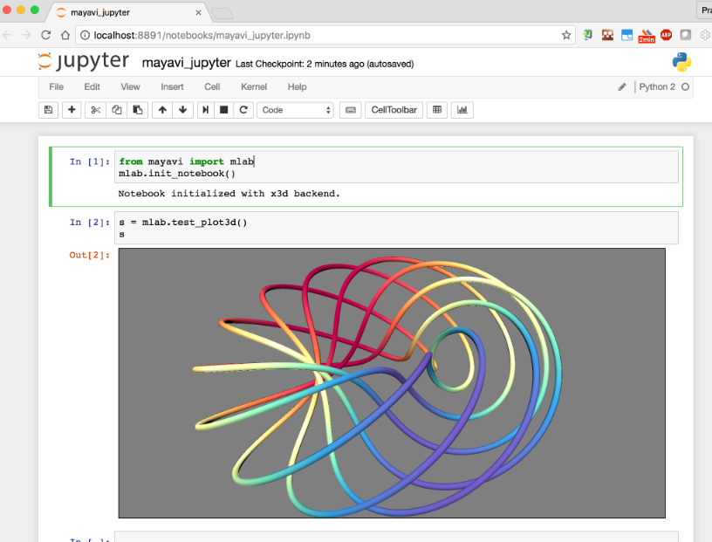

Jupyter Notebooks support various programming languages through different kernels. The default kernel is for Python. Jupyter Notebooks seamlessly integrate with popular data science libraries and tools, such as NumPy, Pandas, Matplotlib, Seaborn, Scikit-learn, and more. This makes it a preferred environment for data analysis and exploration.

***Installation of Jupyter notebook.***

C:\Windows\System32>pip install Jupyter

Create a folder and in that create another folder as JN.

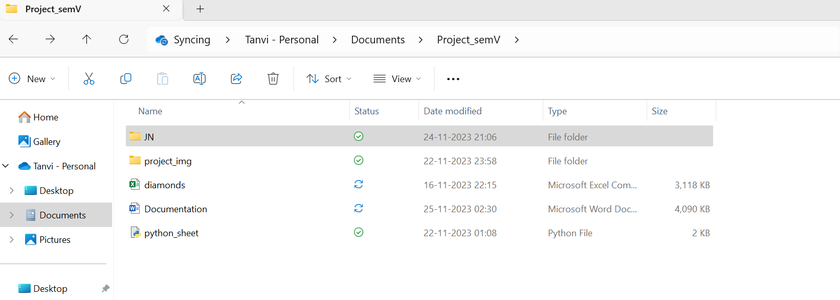

In JN folder in the path write cmd

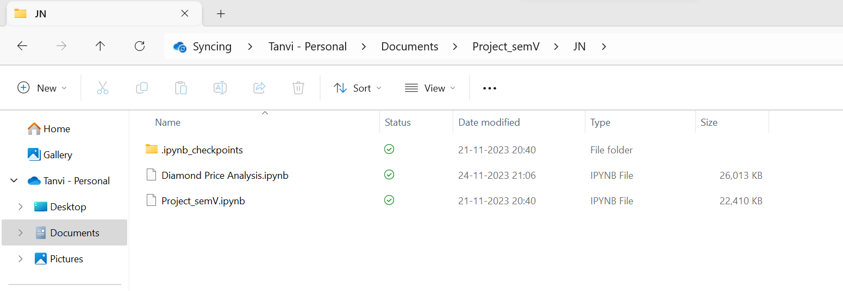



CMD will get opened in that respected folder, type Jupyter notebook. Enter.

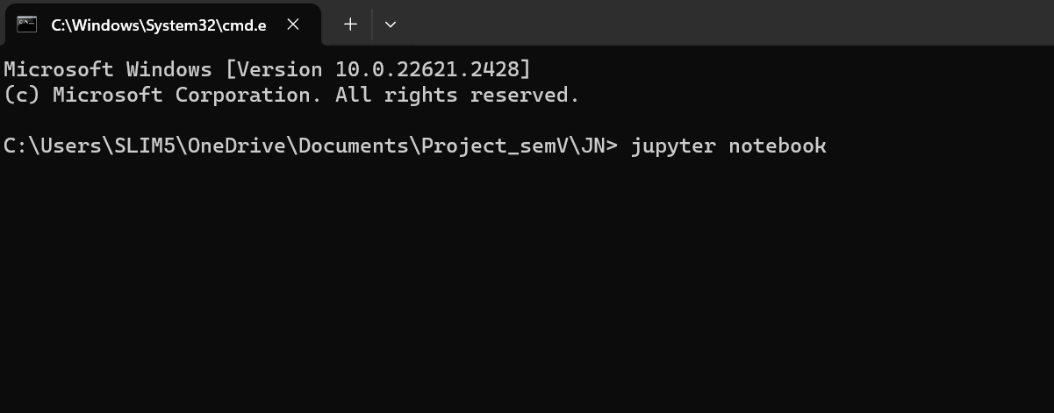

And Jupyter gets opened

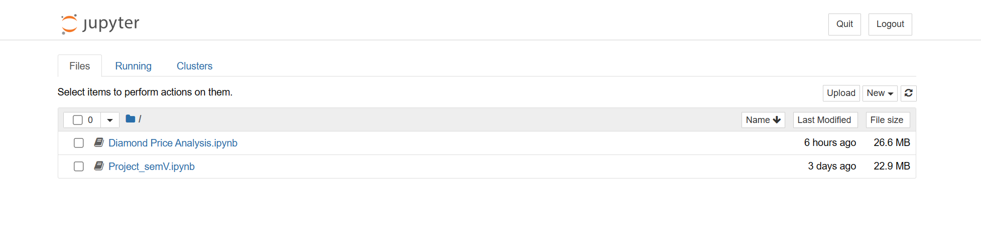

**Project Work**

***Importing Libraries***

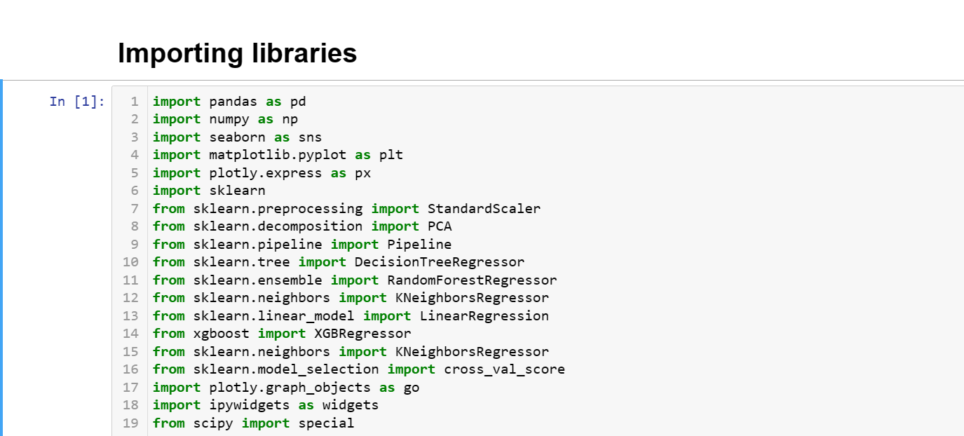

**Pandas (import pandas as pd):**

Used for data manipulation and analysis. It provides data structures like DataFrame for efficient data handling.

**NumPy (import numpy as np):**

A library for numerical operations in Python. It provides support for large, multi-dimensional arrays and matrices, along with mathematical functions.

**Seaborn** **(import seaborn as sns):**

A statistical data visualization library based on Matplotlib. It provides an interface for creating attractive and informative statistical graphics.

**Matplotlib (import matplotlib.pyplot as plt)**:

A widely-used plotting library for creating static, animated, and interactive visualizations in Python.

**Plotly Express** **(import plotly.express as px):**

A high-level interface for creating interactive visualizations. It is particularly useful for creating plots with minimal code.

**Scikit-Learn** **(import sklearn):**

A machine learning library that provides simple and efficient tools for data analysis and modelling. It includes various algorithms for classification, regression, clustering, and more.

**StandardScaler, PCA, Pipeline, DecisionTreeRegressor, RandomForestRegressor, KNeighborsRegressor, LinearRegression (from sklearn.preprocessing import StandardScaler, from sklearn.decomposition import PCA, from sklearn.pipeline import Pipeline, from sklearn.tree import DecisionTreeRegressor, from sklearn.ensemble import RandomForestRegressor, from sklearn.neighbors import KNeighborsRegressor, from sklearn.linear_model import LinearRegression):**

Specific modules and classes from Scikit-Learn used for data preprocessing, dimensionality reduction, and building regression models.

**XGBoost (from xgboost import XGBRegressor):**

An efficient and scalable implementation of gradient boosting. It is commonly used for building high-performance machine learning models.

**cross_val_score** **(from sklearn.model_selection import cross_val_score):**

A function from Scikit-Learn for evaluating the performance of a machine learning model using cross-validation.

**Plotly Graph Objects** **(import plotly.graph_objects as go):**

A lower-level interface for creating sophisticated and customized visualizations using Plotly.

**ipywidgets (import ipywidgets as widgets):**

Interactive HTML widgets for Jupyter notebooks. These widgets can be used to create interactive user interfaces in Jupyter environments.

**scipy.special** **(from scipy import special):**

Part of SciPy, it provides various special functions often used in mathematical physics and engineering.

***Loading the data***

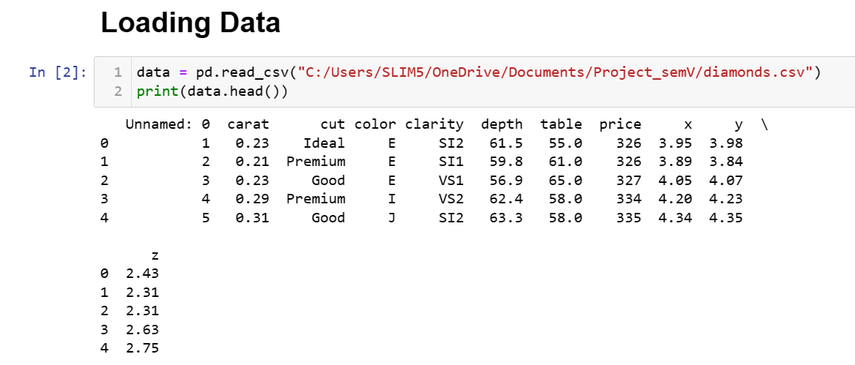

Code:

**data = pd.read_csv("C:/Users/SLIM5/OneDrive/Documents/Project_semV/diamonds.csv")**

**print(data.head())**

appears that you have successfully read a CSV file named "diamonds.csv" into a Pandas DataFrame using the pd.read_csv function. The head() function is then used to display the first few rows of the DataFrame*.*

**print(data)**

Printing the entire DataFrame using print(data) simply typing the variable name (data) and running the cell will display a more user-friendly output.

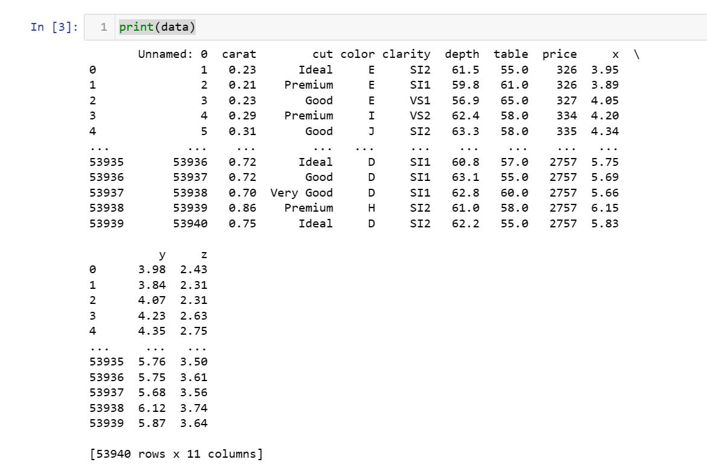

**data.shape**

The data.shape attribute returns a tuple representing the dimensions of your DataFrame.

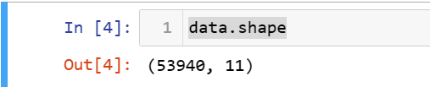

**print(data[['color','price']])**

code print(data[['color','price']]) is correctly printing specific columns ('color' and 'price') from your DataFrame. This will display a table with the 'color' and 'price' columns.

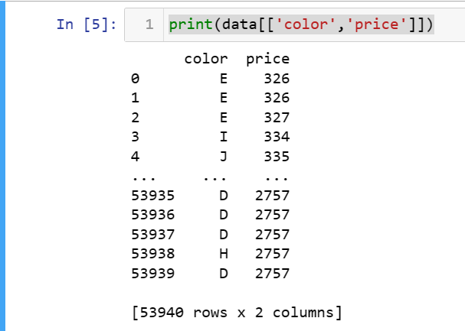

The first column is an index ("Unnamed: 0") and thus we are going to remove it

**data = data.drop(["Unnamed: 0"], axis=1)**

**data.describe()**

dropped the "Unnamed: 0" column from your DataFrame using the drop method. The axis=1 argument indicates that you are dropping a column (as opposed to a row), and the column name is specified within the square brackets.

Now, you are using the describe() method to generate descriptive statistics for the remaining columns in your DataFrame. This method provides summary statistics such as mean, standard deviation, minimum, 25th percentile, median (50th percentile), 75th percentile, and maximum.

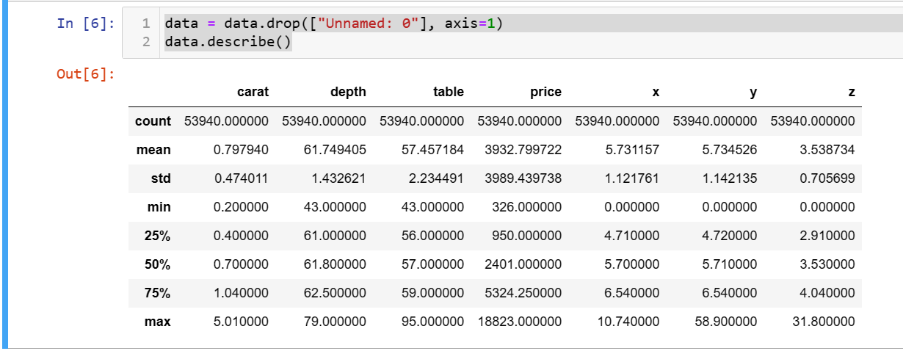

***Exploratory Data Analysis***

**figure1 = px.scatter(data_frame = data, x= "carat", y = "price", size = "depth", color = "cut", trendline = "ols")**

**figure1.show()**

using Plotly Express to create a scatter plot with a trendline based on the "carat," "price," "depth," and "cut" columns in your dataset. The trendline="ols" argument specifies that you want to include an ordinary least squares (OLS) regression line in your scatter plot.

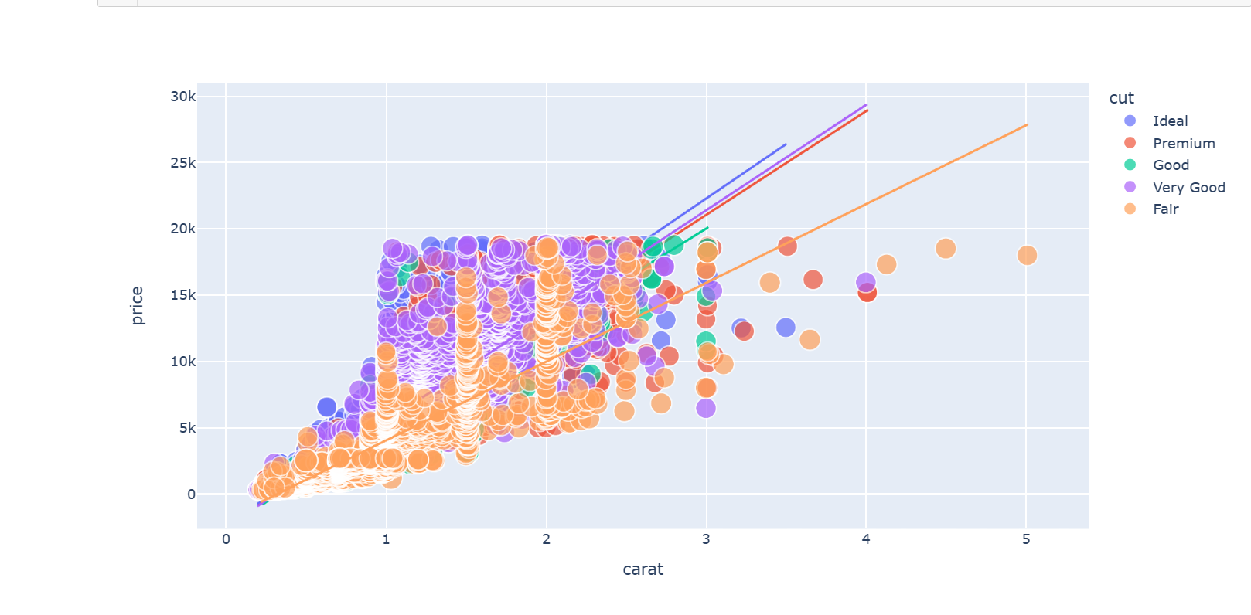

This visualization allows you to explore the relationship between the "carat" and "price" variables, with points coloured by the "cut" category and sized by the "depth" variable. The trendline provides a visual representation of the linear regression relationship between "carat" and "price."

**Why Plotly?**

**Plotly allows for the creation of highly interactive and dynamic visualizations. Users can zoom, pan, hover over data points for details, toggle visibility of certain traces, and more. This is particularly beneficial for exploratory data analysis and creating interactive dashboards.**

*Below are the examples for the Plotly, where we can hover over data points for all the data we need. When the curser is placed on the picture then we get the description of the data.*

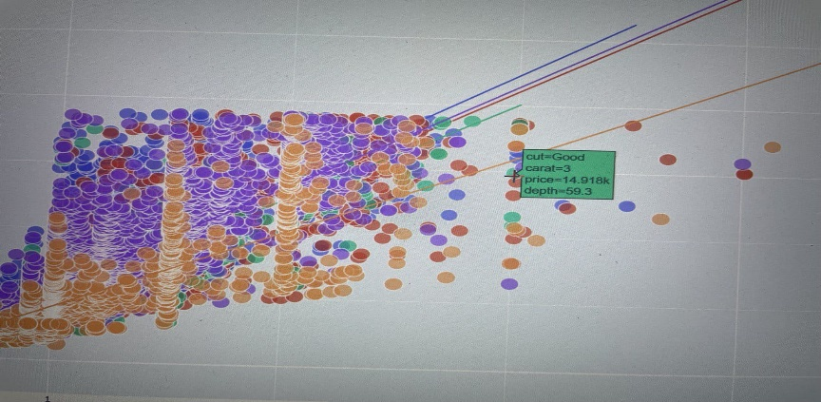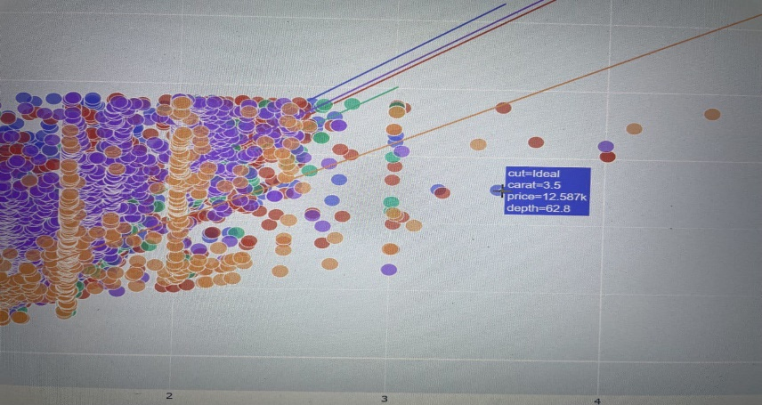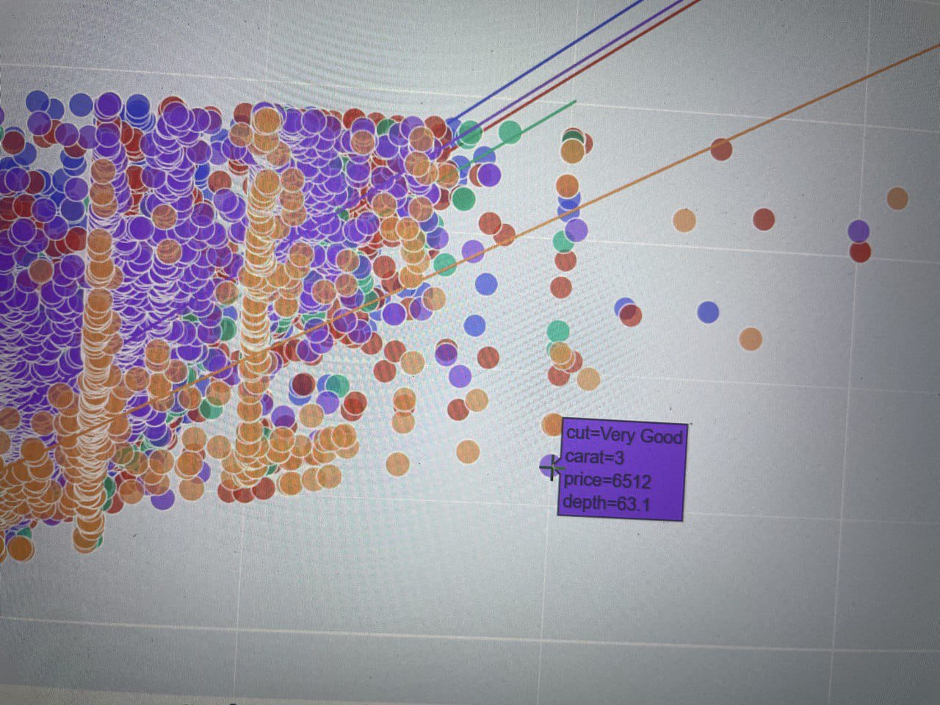

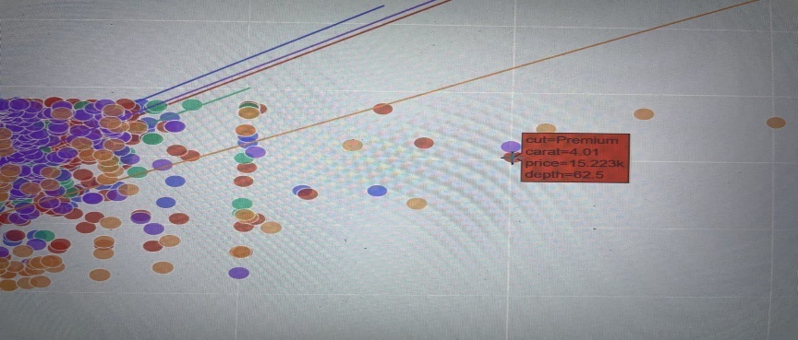

**data["size"] = data["x"] * data["y"]*data["z"]**

**print(data)**

calculating a new column named "size" in your DataFrame, which is the product of the "x," "y," and "z" columns, likely representing the volume or size of some objects described by these dimensions.

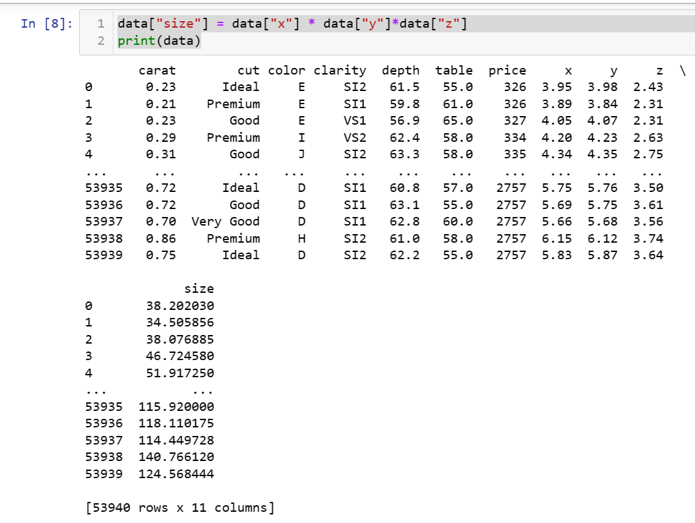

data["x"], data["y"], and data["z"] are Series representing the values in the respective columns.

data["x"] * data["y"] * data["z"] calculates the element-wise product of these three Series, resulting in a new Series.

data["size"] = ... assigns this new Series as a new column in the DataFrame, labeled "size."

print(data) displays the DataFrame with the newly added "size" column.

Now, your DataFrame includes a "size" column, and each row represents the calculated size based on the values in the "x," "y," and "z" columns.

**figure2 = px.scatter(data_frame = data, x = "size", y = "price", size = "size", color = "cut", trendline = "ols")**

**figure2.show()**

creating a scatter plot using Plotly Express with the "size" column on the x-axis, the "price" column on the y-axis, points coloured by the "cut" category, and a trendline based on ordinary least squares (OLS) regression.

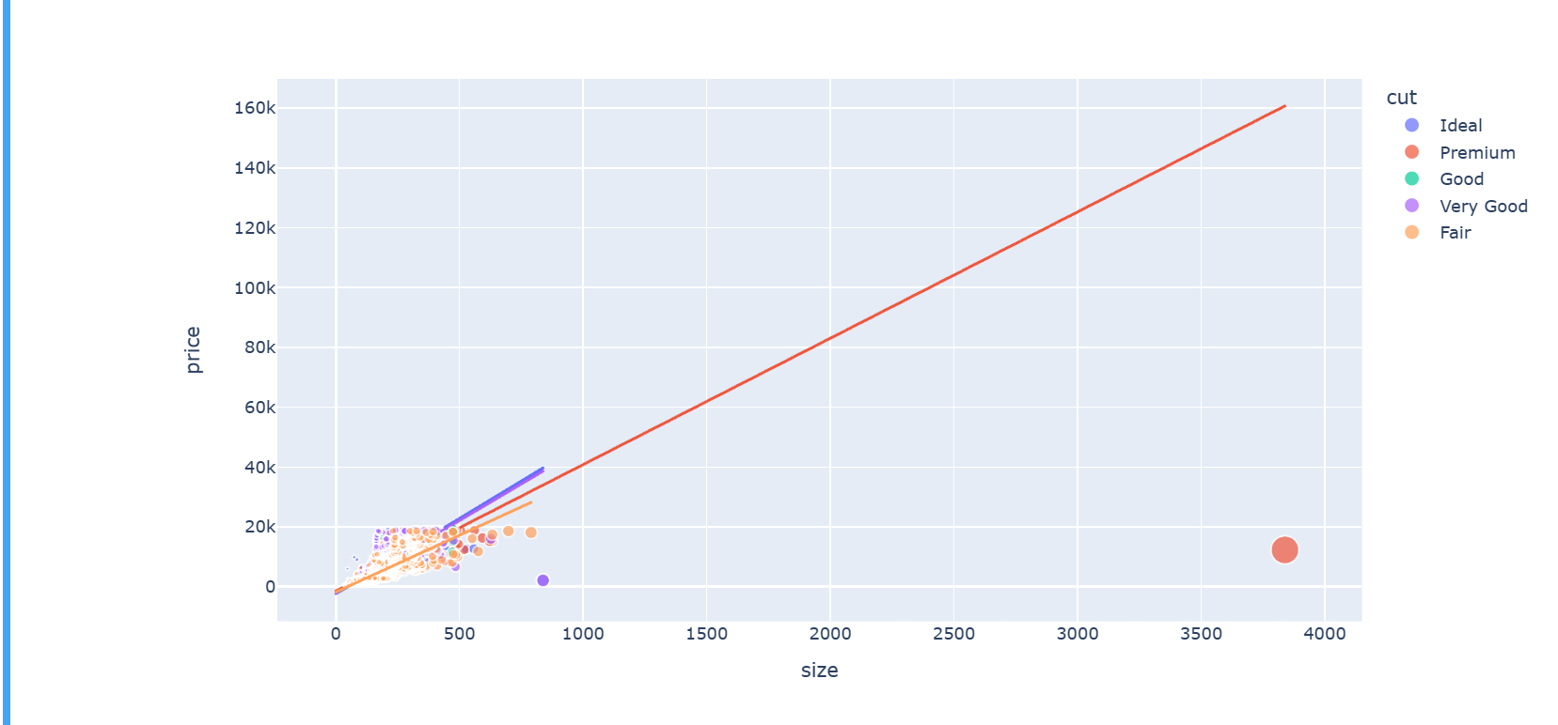

This visualization allows you to explore the relationship between the calculated "size" and "price" variables, with points coloured by the "cut" category. The trendline provides a visual representation of the linear regression relationship between "size" and "price."

The trendline is a straight line that best fits the data points in a linear fashion. It represents the linear regression equation, which describes the relationship between the independent variable (x-axis, "size" in this case) and the dependent variable (y-axis, "price" in this case).

**figure3 = px.box(data, x = "cut", y = "price", color = "color")**

**figure3.show()**

creating a box plot using Plotly Express, where the x-axis represents the "cut" category, the y-axis represents the "price" variable, and the boxes are coloured based on the "color" category.

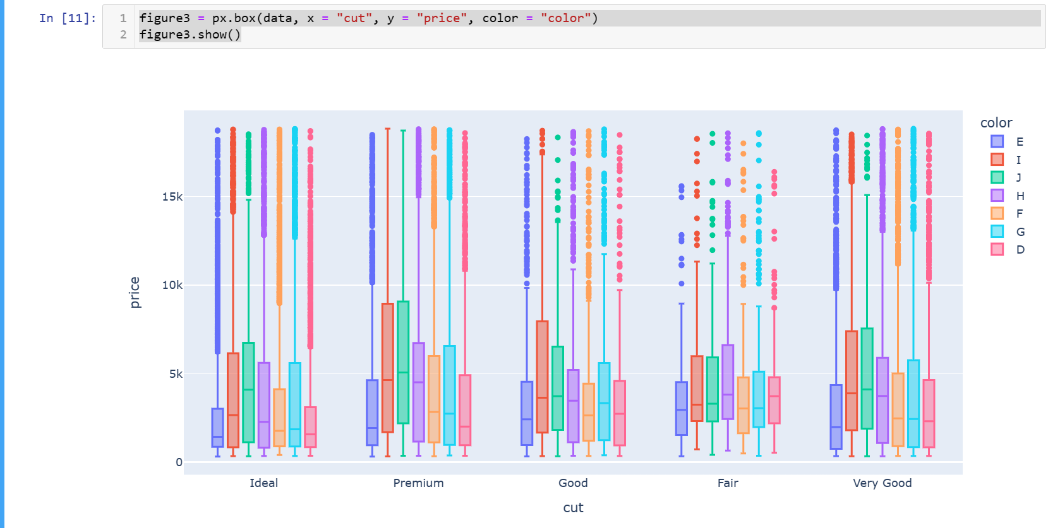

* **px.box:** This function from Plotly Express is used to create a box plot.
* **data:** The DataFrame you are plotting.
* **x="cut":** The variable to be plotted on the x-axis, which is the "cut" category.
* **y="price":** The variable to be plotted on the y-axis, which is the "price" variable.
* **color="color":** The variable used to color the boxes, which is the "color" category.

*The resulting box plot will display the distribution of prices for each level of the "cut" category, with the boxes potentially further differentiated by the "color" category.*

**figure4 = px.box(data, x = "cut", y = "price", color = "clarity")**

**figure4.show()**

creating another box plot using Plotly Express, where the x-axis represents the "cut" category, the y-axis represents the "price" variable, and the boxes are coloured based on the "clarity" category.

This type of visualization can be useful for comparing the distribution of prices within different levels of "cut" and how it varies with "clarity."

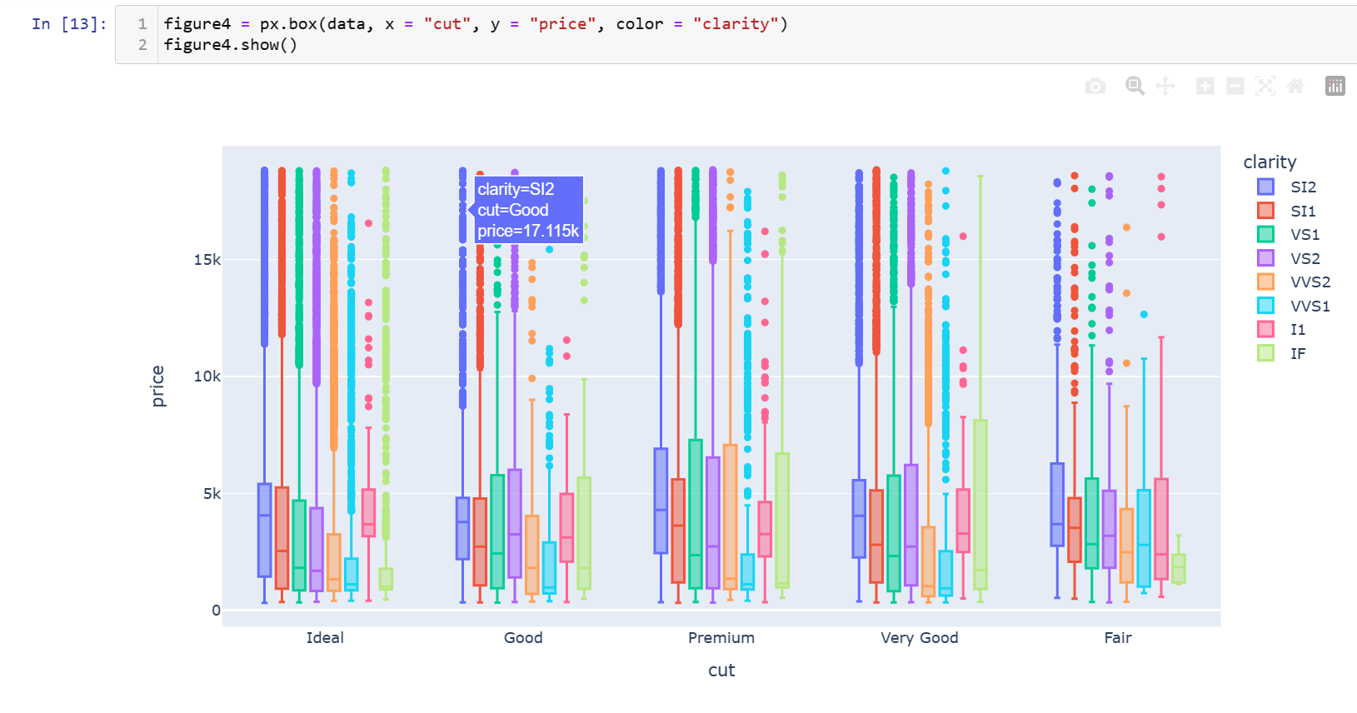

* **px.box:** This function from Plotly Express is used to create a box plot.
* **data:** The DataFrame you are plotting.
* **x="cut":** The variable to be plotted on the x-axis, which is the "cut" category.
* **y="price":** The variable to be plotted on the y-axis, which is the "price" variable.
* **color="clarity":** The variable used to color the boxes, which is the "clarity" category.

The resulting box plot will display the distribution of prices for each level of the "cut" category, with the boxes differentiated by the "clarity" category.

**figure5 = px.scatter(data, x='depth', y='price', trendline='ols',color = "clarity", labels={'depth': 'Depth', 'price': 'Price'},title='Price v/s Depth associated with Clarity')**

**figure5.show()**

creating a scatter plot using Plotly Express, where the x-axis represents the "depth" variable, the y-axis represents the "price" variable, and points are coloured based on the "clarity" category. Additionally, you've added an OLS (Ordinary Least Squares) trendline to show the linear regression relationship between depth and price.

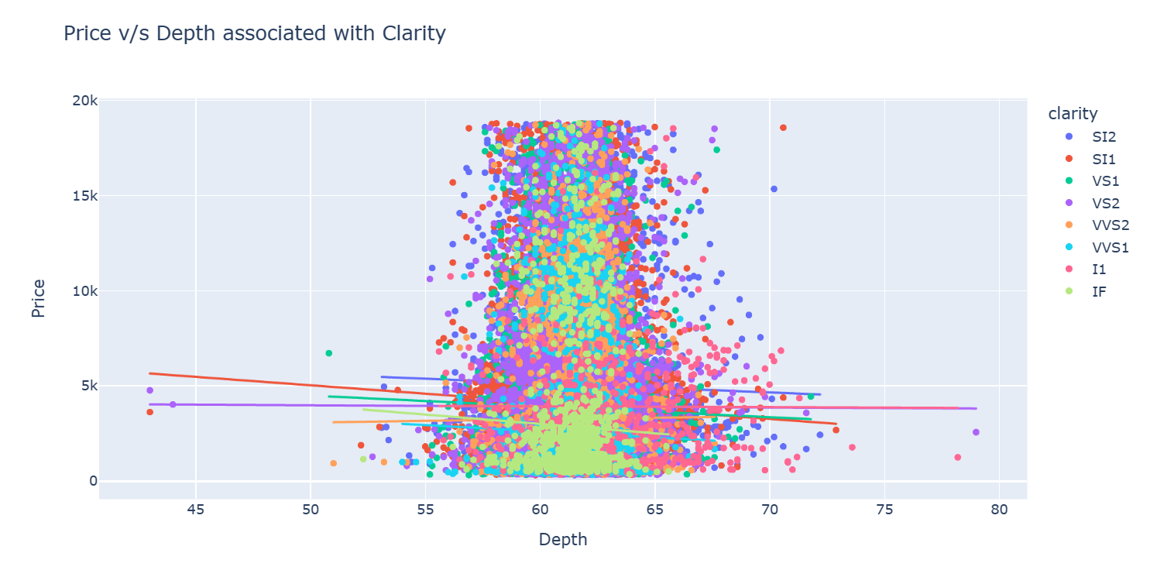

* **px.scatter**: This function from Plotly Express is used to create a scatter plot.
* **data:** The DataFrame you are plotting.
* **x='depth':** The variable to be plotted on the x-axis, which is the "depth" variable.
* **y='price':** The variable to be plotted on the y-axis, which is the "price" variable.
* **trendline='ols':** Specifies the inclusion of an OLS trendline in the plot.
* **color="clarity":** The variable used to color the points, which is the "clarity" category.
* **labels={'depth': 'Depth', 'price': 'Price'}:** Custom labels for the x and y axes.
* **title='Price v/s Depth associated with Clarity':** The title of the plot.

*The resulting scatter plot should show the relationship between "depth" and "price" with points coloured by the "clarity" category. The trendline provides a visual representation of the linear regression relationship.*

**figure6 = px.violin(data, x='cut', y='price', box=True, color = "cut")**

**figure6.show()**

creating a violin plot using Plotly Express, where the x-axis represents the "cut" category, the y-axis represents the "price" variable, and the violins are coloured based on the "cut" category. Additionally, you've included box plots within each violin.

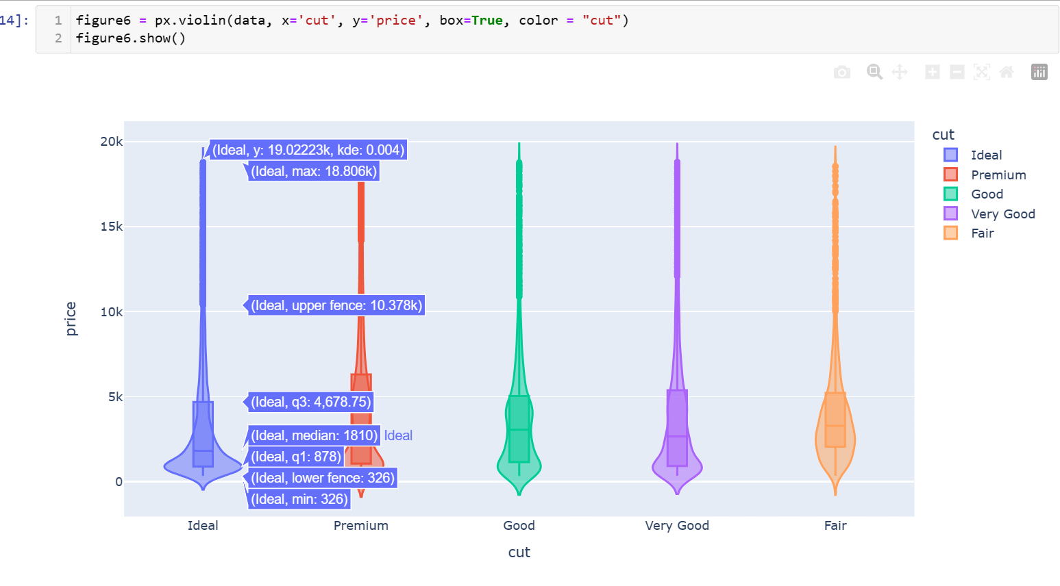

* **px.violin:** This function from Plotly Express is used to create a violin plot.
* **data:** The DataFrame you are plotting.
* **x='cut':** The variable to be plotted on the x-axis, which is the "cut" category.
* **y='price':** The variable to be plotted on the y-axis, which is the "price" variable.
* **box=True:** Specifies the inclusion of box plots within each violin.
* **color="cut":** The variable used to color the violins, which is the "cut" category.

The resulting violin plot should display the distribution of prices for each level of the "cut" category. The violins provide a visual representation of the data distribution, and the box plots within each violin offer additional summary statistics.

**cmap = sns.diverging_palette(70,20,s=50, l=40, n=6,as_cmap=True)**

**corrmat=data.corr()**

**f, ax = plt.subplots(figsize=(12,12))**

**sns.heatmap(corrmat,cmap=cmap,annot=True)**

using Seaborn to create a heatmap of the correlation matrix (corrmat) of your DataFrame (data). The sns.diverging_palette is used to create a color palette for the heatmap.

This heatmap allows you to visualize the correlation between different variables in your dataset. Positive correlations are represented by lighter colours, negative correlations by darker colours, and the strength of the correlation is indicated by the intensity of the color.

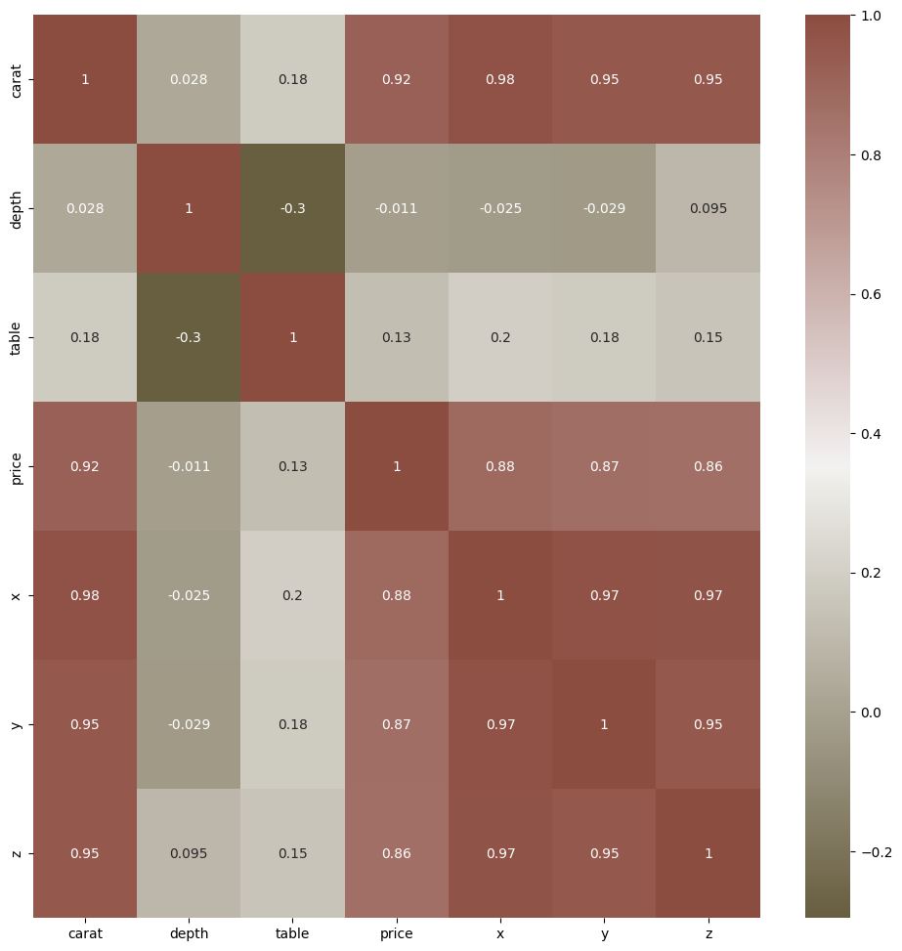

* **sns.diverging_palette:** This function creates a diverging color palette. The parameters control the color scheme, saturation, lightness, and the number of colours in the palette.
* **data.corr():** This calculates the correlation matrix of your DataFrame.
* **sns.heatmap:** This function from Seaborn is used to create a heatmap. The cmap parameter specifies the color map, and annot=True adds numerical annotations to the heatmap.
* **plt.show():** This displays the heatmap.

**Points to notice:**

* "x", "y" and "z" show a high correlation to the target column.
* "depth", "cut" and "table" show low correlation. We could consider dropping but let's keep it.

**category = data[['cut', 'color', 'clarity']].columns.to_list()**

**fig = plt.figure(figsize=(15, 5))**

**plt.suptitle("Categorical Variables", size=20, weight='bold')**

**ax1 = plt.subplot(131)**

**sns.countplot(data=data, x=category[0], ax=ax1, linewidth=2, palette='viridis')**

**for s in ['left', 'right', 'top', 'bottom']:**

**ax1.spines[s].set_visible(False)**

**ax2 = plt.subplot(132, sharey=ax1)**

**sns.countplot(data=data, x=category[1], ax=ax2, linewidth=2, palette='viridis')**

**for s in ['left', 'right', 'top', 'bottom']:**

**ax2.spines[s].set_visible(False)**

**ax3 = plt.subplot(133, sharey=ax1)**

**sns.countplot(data=data, x=category[2], ax=ax3, linewidth=2, palette='viridis')**

**for s in ['left', 'right', 'top', 'bottom']:**

**ax3.spines[s].set_visible(False)**

**plt.show()**

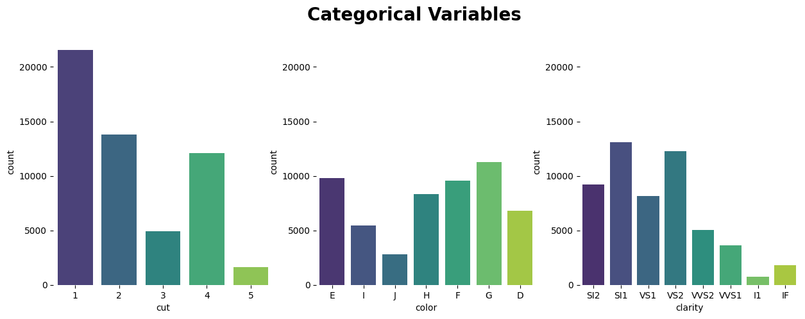

creates subplots for each categorical variable ('cut', 'color', 'clarity') using Seaborn's countplot and removes the spines for a cleaner appearance.

count plots for three categorical variables (cut, color, and clarity). Each subplot represents the count distribution of a specific categorical variable.

A couple of points to note:

Share Y-Axis: You're using sharey=ax1 for the second and third subplots, which means they share the same y-axis. This can be helpful for better comparison.

Spines Visibility: You're setting the visibility of spines to False for each subplot, providing a cleaner look without unnecessary frame lines.

Color Palette: You've used the 'viridis' color palette, which is a perceptually uniform and visually pleasing color map.

Suptitle: You've added a super title for the entire figure, which is a good practice to provide an overall description.

**def correlation_matrix(dataframe, figsize_x, figsize_y):**

**corr = dataframe.corr()**

**f, ax = plt.subplots(figsize=(figsize_x, figsize_y))**

**mask = np.triu(np.ones_like(corr))**

**sns.heatmap(corr, annot=True, mask=mask, linewidths=1, cmap="Blues", fmt='.2f', square=True)**

**plt.title('Correlation Matrix', fontsize=15)**

**# Add axis labels**

**ax.set_xticklabels(ax.get_xticklabels(), rotation=45, horizontalalignment='right')**

**ax.set_yticklabels(ax.get_yticklabels(), rotation=0, horizontalalignment='right')**

**return ax**

**correlation_matrix(data, 10, 7)**

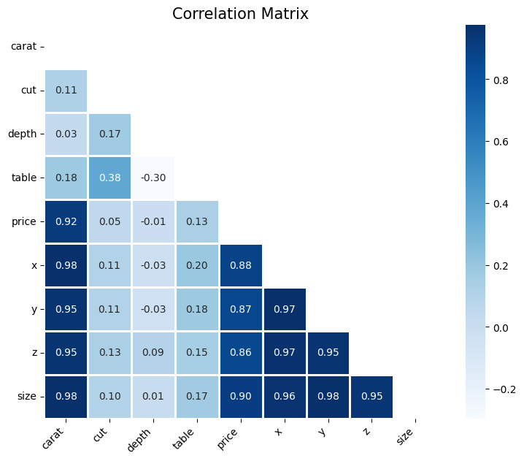

correlation_matrix function now includes enhancements for better readability and presentation. The addition of axis labels with rotation and horizontal alignment can be especially helpful when dealing with a larger number of features.

**sns_plot = sns.pairplot(data)**

using the pairplot function from the seaborn library to create a pair plot for the given dataset (data). The pairplot function automatically generates a matrix of scatterplots for all pairs of variables in the dataset, along with histograms along the diagonal.

1. seaborn.pairplot(data): This function creates a pair plot for the specified dataset (data). Each subplot in the grid represents the relationship between two variables, and the diagonal contains histograms for each variable.
2. sns_plot: This variable is assigned to the output of the pairplot function. It allows you to further customize or analyze the pair plot if needed.

pairplot will use scatterplots for non-diagonal subplots and histograms for diagonal subplots. This visualization is useful for exploring relationships between variables, identifying patterns, and getting an overall sense of the data distribution. Adjustments to the pair plot, such as customizing colors or adding regression lines, can be made by providing additional arguments to the pairplot function.

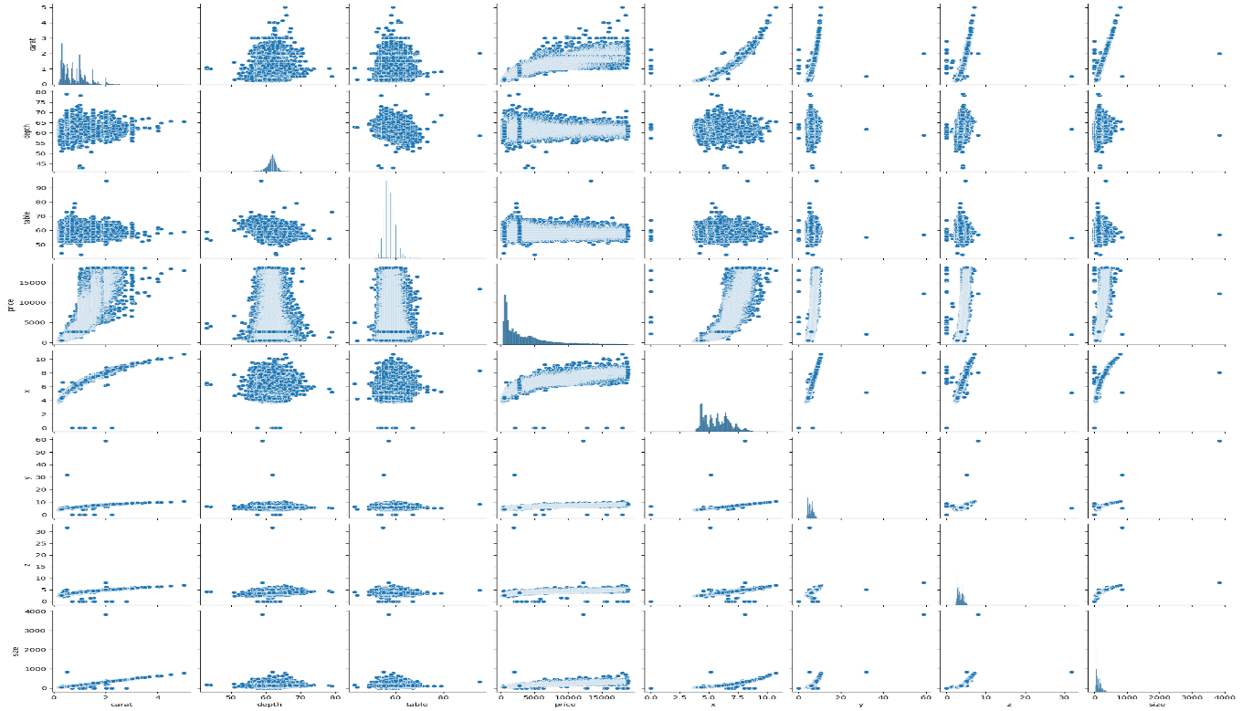

***Data Preprocessing***

Data preprocessing is a crucial step in the data analysis and machine learning pipeline. It involves cleaning and transforming raw data into a format that can be effectively used for analysis or used as input for machine learning models. The main goals of data preprocessing are to enhance the quality of the data, address missing values, handle outliers, and prepare the data for further analysis or model training.

**data.info()**

data.info() method in Pandas provides a concise summary of the DataFrame, including information about the data types, non-null values, and memory usage. It's a handy method to quickly assess the structure and characteristics of your dataset.

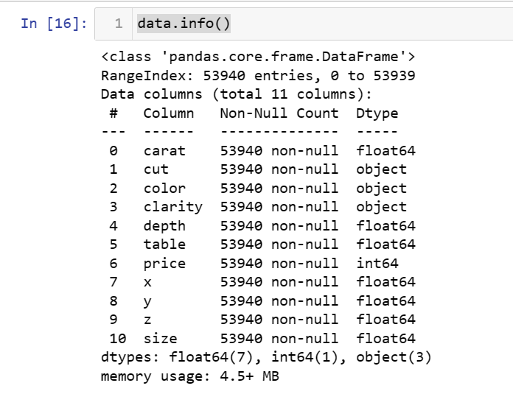

**correlation = data.corr()**

**print(correlation["price"].sort_values(ascending=False))**

calculating the correlation coefficients between the "price" column and other columns in your DataFrame (data) and then printing the sorted correlations in descending order. This can help you identify which features are most strongly correlated (positively or negatively) with the "price" variable.

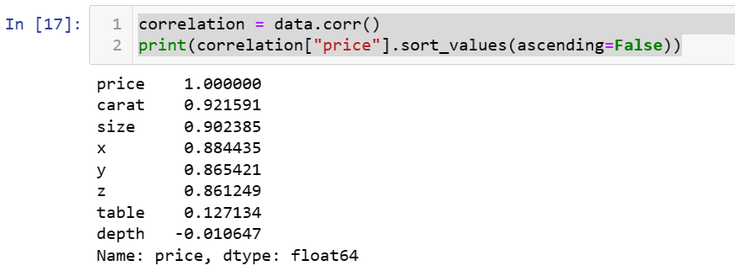

This will output a series of correlation coefficients, sorted in descending order based on their correlation with the "price" column. The values closer to 1 or -1 indicate a stronger positive or negative correlation, respectively.

* The "price" column has a perfect positive correlation with itself (correlation coefficient of 1.000000).
* The "carat" column has a high positive correlation (0.921591) with the "price" column, indicating a strong positive relationship.
* The "depth" column has a small negative correlation (-0.010647) with the "price" column, indicating a weak negative relationship.

You can interpret the correlation coefficients as follows:

* Close to 1: Strong positive correlation
* Close to -1: Strong negative correlation
* Close to 0: Weak or no correlation

***Machine Learning Model***

A machine learning model is a mathematical representation or a computational system that is trained to make predictions or decisions based on data. It is a core component of machine learning, a subfield of artificial intelligence (AI) that focuses on the development of algorithms and models capable of learning patterns and making predictions without explicit programming.

**data["cut"] = data["cut"].map({"Ideal": 1,**

**"Premium": 2,**

**"Good": 3,**

**"Very Good": 4,**

**"Fair": 5})**

using the map function in Pandas to convert the values in the "cut" column from categorical labels to numerical values. The mapping is as follows:

* "Ideal" is mapped to 1
* "Premium" is mapped to 2
* "Good" is mapped to 3
* "Very Good" is mapped to 4
* "Fair" is mapped to 5

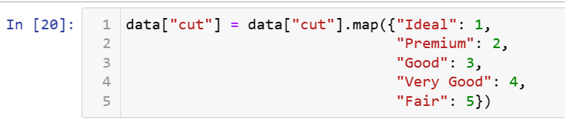

This operation is useful when you want to convert categorical variables into a numerical format, which can be necessary for certain machine learning algorithms that require numerical input.

Keep in mind that this transformation is based on an ordinal mapping, implying an implicit order among the categories. If the "cut" variable represents categories with no inherent order, you might consider using one-hot encoding instead.

**from sklearn.model_selection import train_test_split**

**x = np.array(data[["carat", "cut", "size"]])**

**y = np.array(data[["price"]])**

**xtrain, xtest, ytrain, ytest = train_test_split(x, y,**

**test_size=0.10,**

**random_state=42)**

using the train_test_split function from scikit-learn to split your dataset into training and testing sets for machine learning. The features (x) include columns "carat," "cut," and "size," and the target variable (y) is the "price."

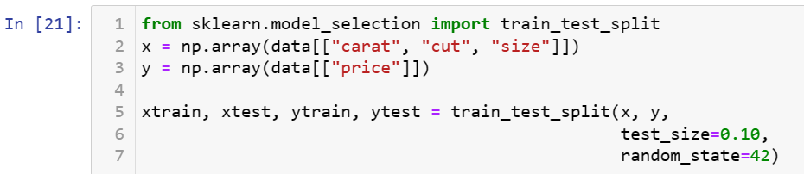

* **train_test_split:** This function randomly splits the dataset into training and testing sets.
* **x:** The features used for prediction (in this case, columns "carat," "cut," and "size").
* **y:** The target variable to be predicted (in this case, "price").
* **test_size=0.10:** Specifies that 10% of the data will be used for testing, and the remaining 90% will be used for training.
* **random_state=42:** Sets the random seed for reproducibility, ensuring that the same random split is obtained each time the code is run

will have four sets of data: xtrain (features for training), xtest (features for testing), ytrain (target variable for training), and ytest (target variable for testing). These sets can be used to train and evaluate machine learning models.

**pipeline_lr=Pipeline([("scalar1",StandardScaler()),("lr_classifier",LinearRegression())])**

**pipeline_dt=Pipeline([("scalar2",StandardScaler()),("dt_classifier",DecisionTreeRegressor())])**

**pipeline_rf=Pipeline([("scalar3",StandardScaler()),("rf_classifier",RandomForestRegressor())])**

**pipeline_kn=Pipeline([("scalar4",StandardScaler()),("rf_classifier",KNeighborsRegressor())])**

**pipeline_xgb=Pipeline([("scalar5",StandardScaler()),("rf_classifier",XGBRegressor())])**

**pipelines = [pipeline_lr, pipeline_dt, pipeline_rf, pipeline_kn, pipeline_xgb]**

**pipe_dict = {0: "LinearRegression", 1: "DecisionTree", 2: "RandomForest",3: "KNeighbors", 4: "XGBRegressor"}**

**for pipe in pipelines:**

**pipe.fit(xtrain, ytrain)**

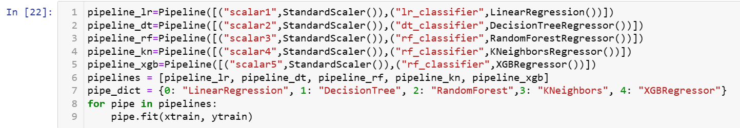

creating a set of pipelines for different regression models using scikit-learn. The pipelines include a standard scaler for feature scaling and various regression models such as Linear Regression, Decision Tree Regressor, Random Forest Regressor, K-Nearest Neighbors Regressor, and XGBoost Regressor.

The loop at the end of the code fits each pipeline to the training data (xtrain, ytrain). After running this code, you'll have trained models for Linear Regression, Decision Tree Regression, Random Forest Regression, K-Nearest Neighbors Regression, and XGBoost Regression.

1. Linear Regression:

* Linear regression is a statistical method used for modelling the relationship between a dependent variable (target) and one or more independent variables (features) by fitting a linear equation to the observed data.
* Assumes a linear relationship between the features and the target. The model coefficients represent the slope and intercept of the linear equation.

1. Decision Tree Regression:

* Decision tree regression involves creating a tree-like model of decisions to make predictions. The tree is constructed by recursively partitioning the data into subsets based on features.
* Non-linear model that can capture complex relationships in the data. Prone to overfitting but can be regularized.

1. Random Forest Regression:

* Random Forest is an ensemble learning method that builds multiple decision trees and merges their predictions. It aims to improve predictive accuracy and control overfitting.
* Combines the strengths of individual decision trees. Provides feature importance rankings. Robust and less prone to overfitting compared to a single decision tree.

1. K-Nearest Neighbors Regression:

* K-Nearest Neighbors (KNN) regression predicts the target variable by averaging the values of its k-nearest neighbors in the feature space.
* Instance-based learning. The prediction is influenced by the k nearest data points. Non-parametric and can capture complex patterns.

1. XGBoost Regression:

* XGBoost (Extreme Gradient Boosting) is a popular gradient boosting algorithm that builds a series of weak learners (typically decision trees) and combines their predictions to improve accuracy.
* Gradient boosting technique that minimizes a loss function. Regularization to prevent overfitting. Handles missing values and supports parallel processing.

These models are used in various regression tasks, such as predicting house prices, stock prices, or any continuous target variable based on input features. The choice of the model depends on the characteristics of the data, the underlying assumptions, and the desired trade-offs between interpretability and predictive performance. It's common to try multiple models and compare their performance on a validation or test set before selecting the final model.

In essence, regression analysis provides a systematic and quantitative approach to understanding and predicting diamond prices. It is a foundational step in the development of a diamond price prediction model, providing actionable insights for businesses and stakeholders in the diamond industry.

**cv_results_rms = []**

**for i, model in enumerate(pipelines):**

**cv_score = cross_val_score(model, xtrain,ytrain,scoring="neg_root_mean_squared_error", cv=10)**

**cv_results_rms.append(cv_score)**

**print("%s: %f " % (pipe_dict[i], cv_score.mean()))**

using the cross_val_score function from scikit-learn to perform cross-validation and evaluate the performance of each regression model using the negative root mean squared error (scoring="neg_root_mean_squared_error").

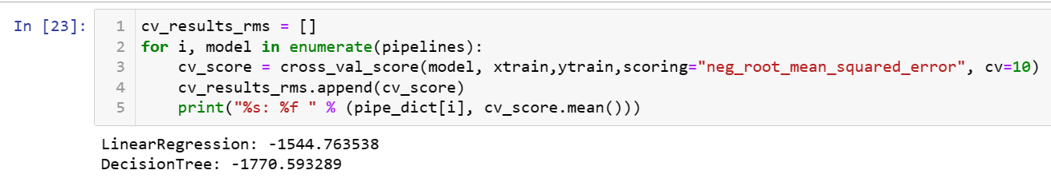

**

This code iterates over each pipeline (each regression model), calculates the negative root mean squared error for each fold in the cross-validation (using 10 folds), and prints the mean cross-validation score for each model.

The negative root mean squared error is used as the scoring metric, and taking the negative is a common convention in scikit-learn when using cross_val_score because it assumes that higher values are better for the scoring metric.

**pred = pipeline_xgb.predict(xtest)**

using the trained XGBoost regression model (pipeline_xgb) to make predictions on the test set (xtest). The predicted values are stored in the variable pred.



the variable pred contains the predicted values for the target variable based on the features in the test set (xtest). You can compare these predictions with the actual target values (ytest) to evaluate the model's performance.

**print("R^2:",metrics.r2_score(ytest, pred))**

**print("Adjusted R^2:",1 - (1-metrics.r2_score(ytest, pred))*(len(ytest)-1)/(len(ytest)-xtest.shape[1]-1))**

**print("MAE:",metrics.mean_absolute_error(ytest, pred))**

**print("MSE:",metrics.mean_squared_error(ytest, pred))**

**print("RMSE:",np.sqrt(metrics.mean_squared_error(ytest, pred)))**

using scikit-learn's metrics module to evaluate the performance of your regression model.

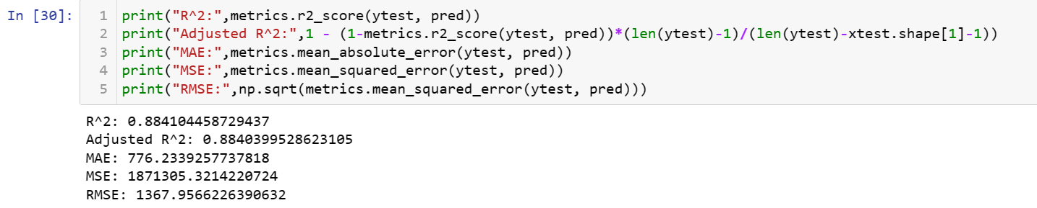

* R-squared (R^2): Measures the proportion of the variance in the dependent variable that is predictable from the independent variables. Ranges from 0 to 1, with higher values indicating a better fit.
* Adjusted R-squared: Similar to R-squared but adjusted for the number of predictors in the model. It penalizes the inclusion of irrelevant predictors.
* Mean Absolute Error (MAE): Represents the average absolute difference between the predicted and actual values. It provides a measure of the model's accuracy.
* Mean Squared Error (MSE): Represents the average squared difference between the predicted and actual values. It amplifies the impact of large errors.
* Root Mean Squared Error (RMSE): Represents the square root of the MSE. It's in the same unit as the target variable and provides a more interpretable measure of error.

These metrics give you insights into different aspects of your regression model's performance. Depending on your specific goals, you might prioritize one metric over another. For example, lower values of MAE, MSE, and RMSE are desirable, while higher R^2 and adjusted R^2 values indicate better explanatory power.

**from sklearn.ensemble import RandomForestRegressor**

**model = RandomForestRegressor()**

**model.fit(xtrain, ytrain)**

creating and training a Random Forest Regressor model using scikit-learn.

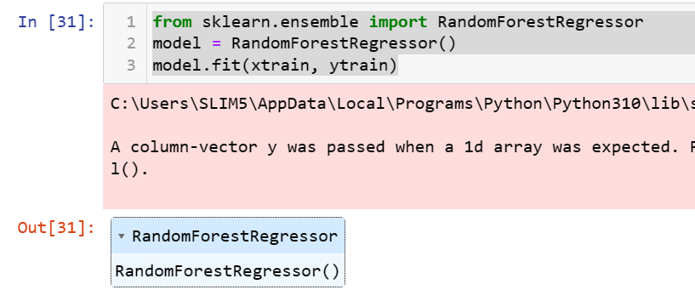

imports the RandomForestRegressor class from scikit-learn, creates an instance of the model, and then trains it on the training data (xtrain and ytrain).

After running this code, the model variable now contains a trained Random Forest Regressor, and you can use it to make predictions on new data or evaluate its performance.

**print("Diamond Price Prediction")**

**a = float(input("Carat Size: "))**

**b = int(input("Cut Type (Ideal: 1, Premium: 2, Good: 3, Very Good: 4, Fair: 5): "))**

**c = float(input("Size: "))**

**features = np.array([[a, b, c]])**

**print("Predicted Diamond's Price (in $) = ", model.predict(features))**

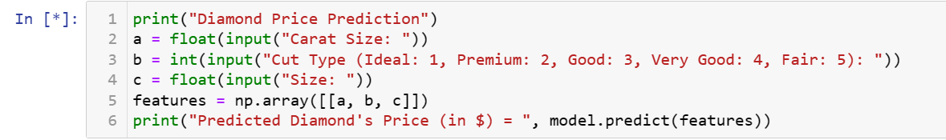

trying to make predictions for diamond prices using the trained Random Forest Regressor (model).

This code prompts the user to input values for carat size, cut type, and size. It then creates a feature array based on the user input and uses the trained Random Forest Regressor (model) to predict the diamond's price.

Make sure that the input values are consistent with the features used during the training of the model. Additionally, consider adding input validation or error handling to ensure that the user provides valid input.

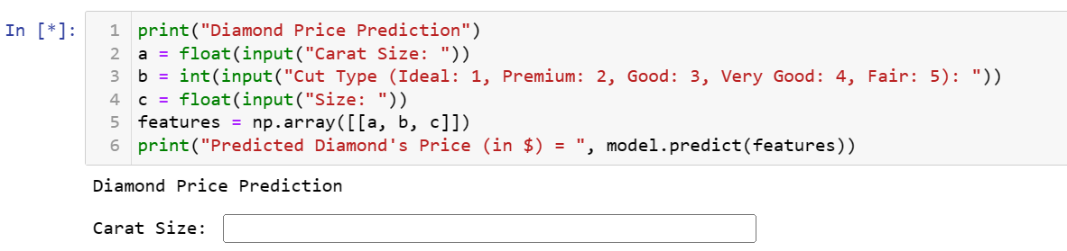

***Final Output***

***Entering the carat size of the diamond you bought.***

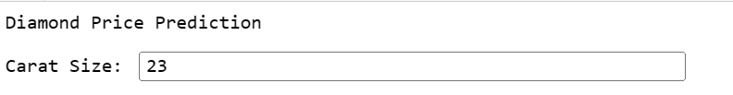

***Enter the cut-type of the diamond. (Entering 4 : Very Good)***

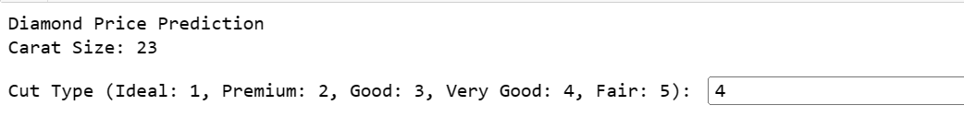

***Enter the Size***

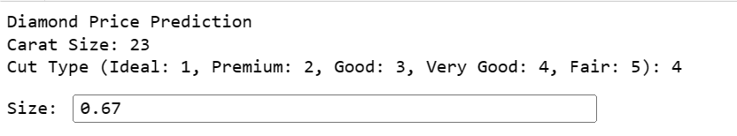

***And we get the predicted diamond price.***

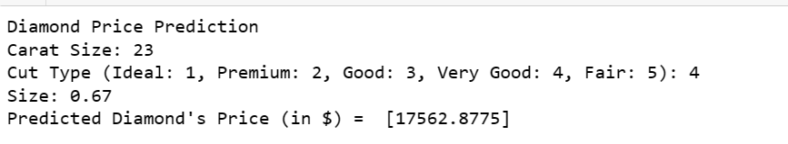

**Carat Size: 23**

**Cut Type : 4**

**Size: 0.67**

**Predicted Diamond’s Price (in $) = [17562.8775]**

Here, we got a predicted value as $17562 for the diamond of carat size as 23, Cut type as very good and size as 0.67 kg.

(The price predicted in dollars is because the data is the dollars)

**All Coding and Screenshots.**

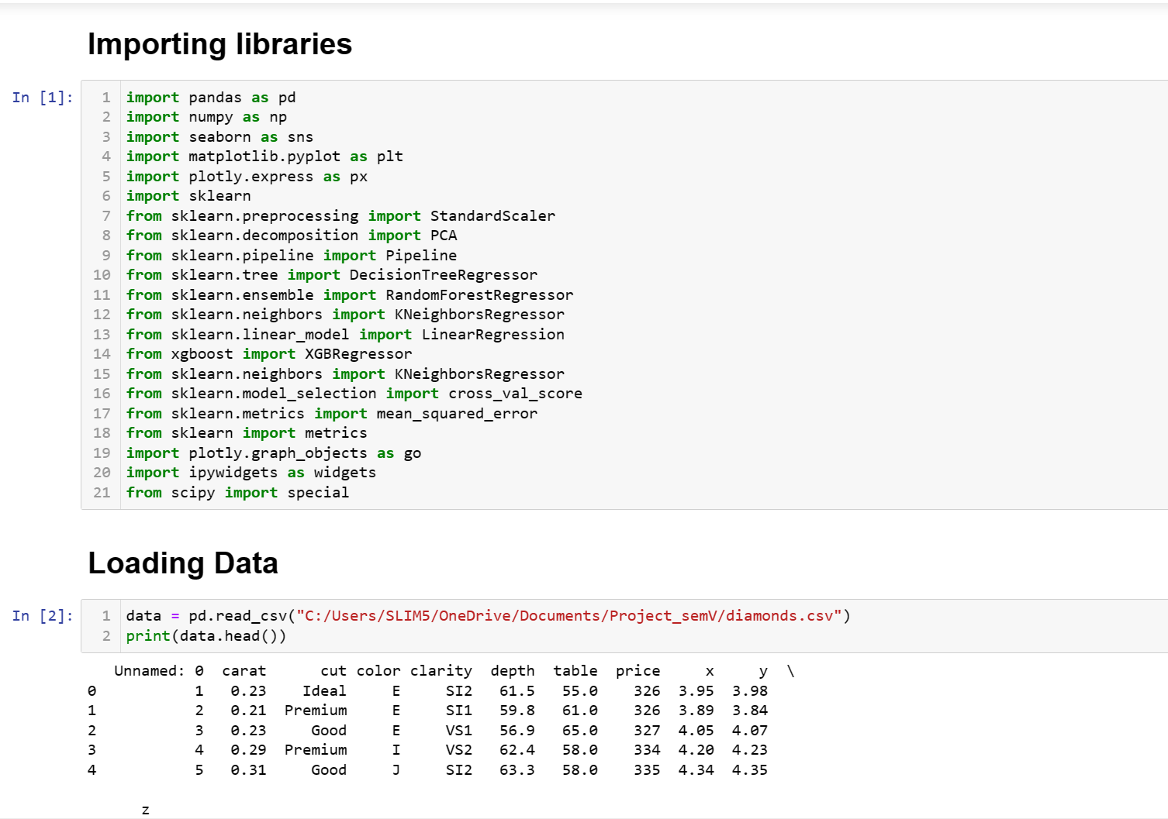

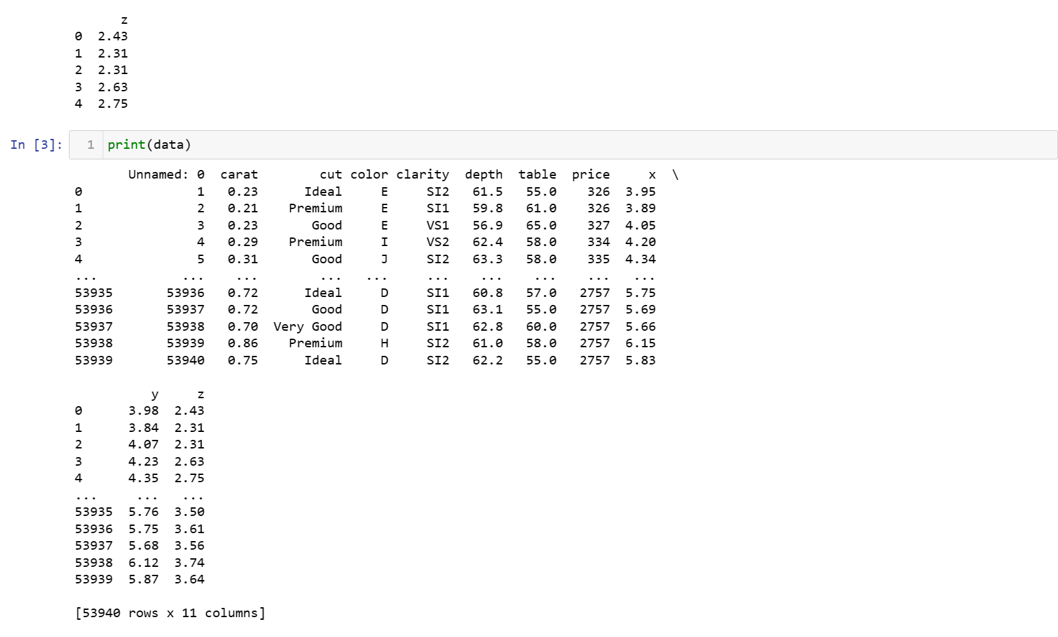

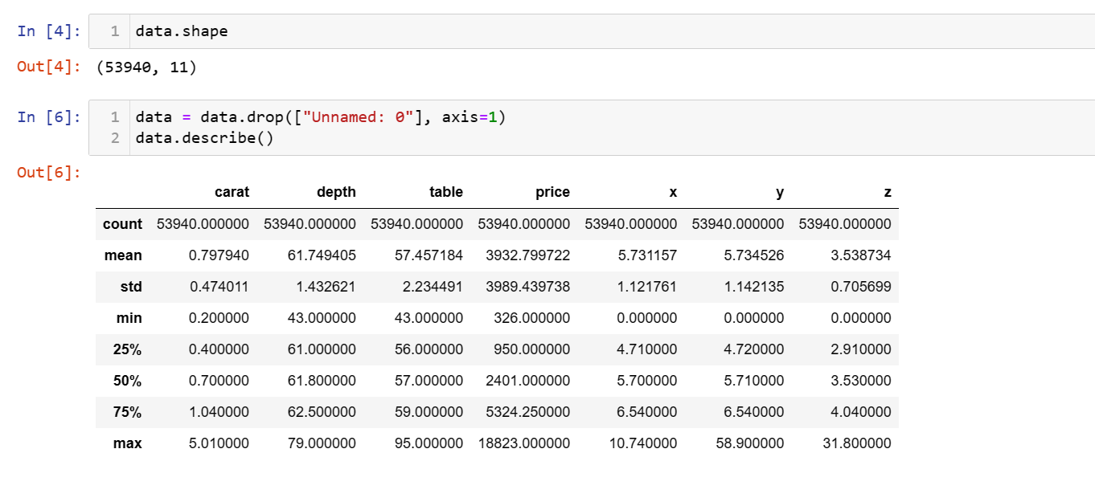

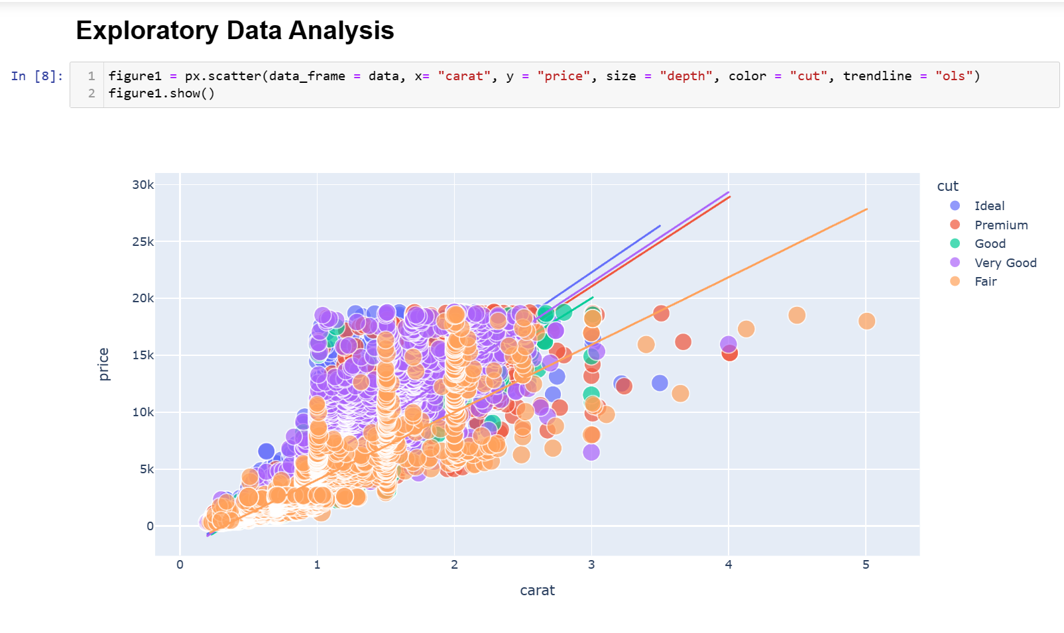

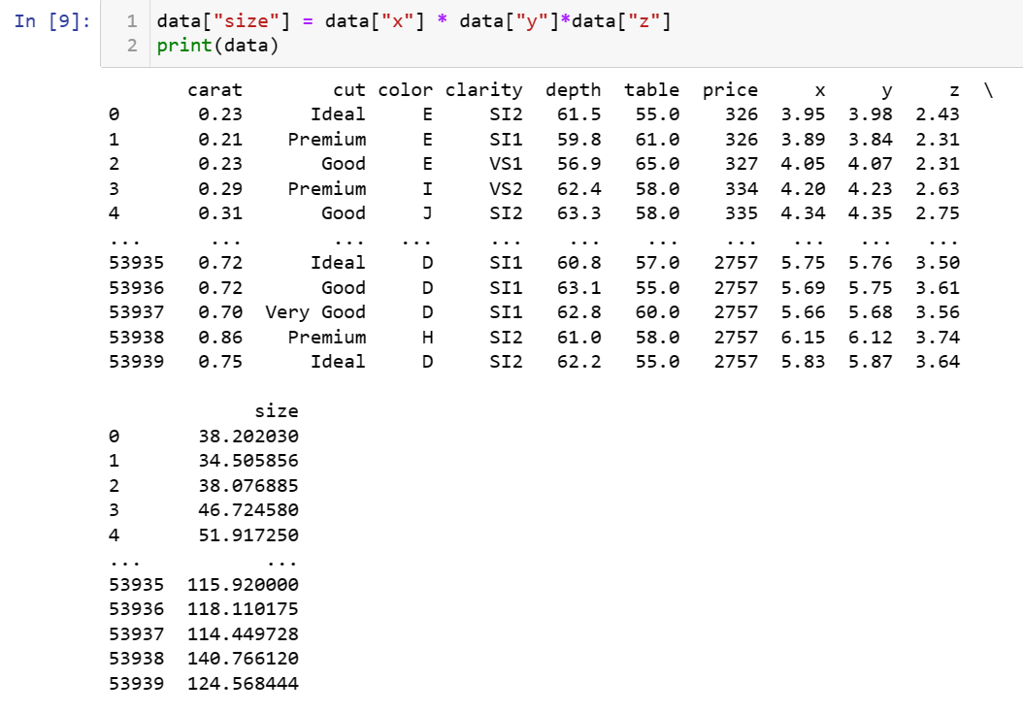

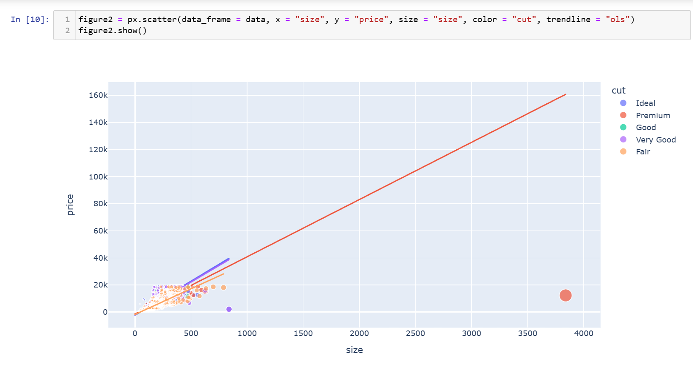

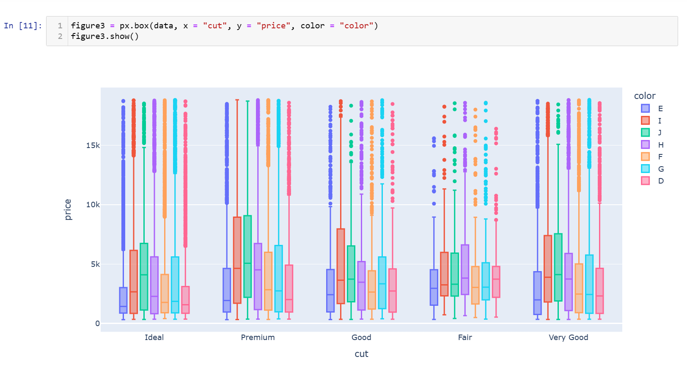

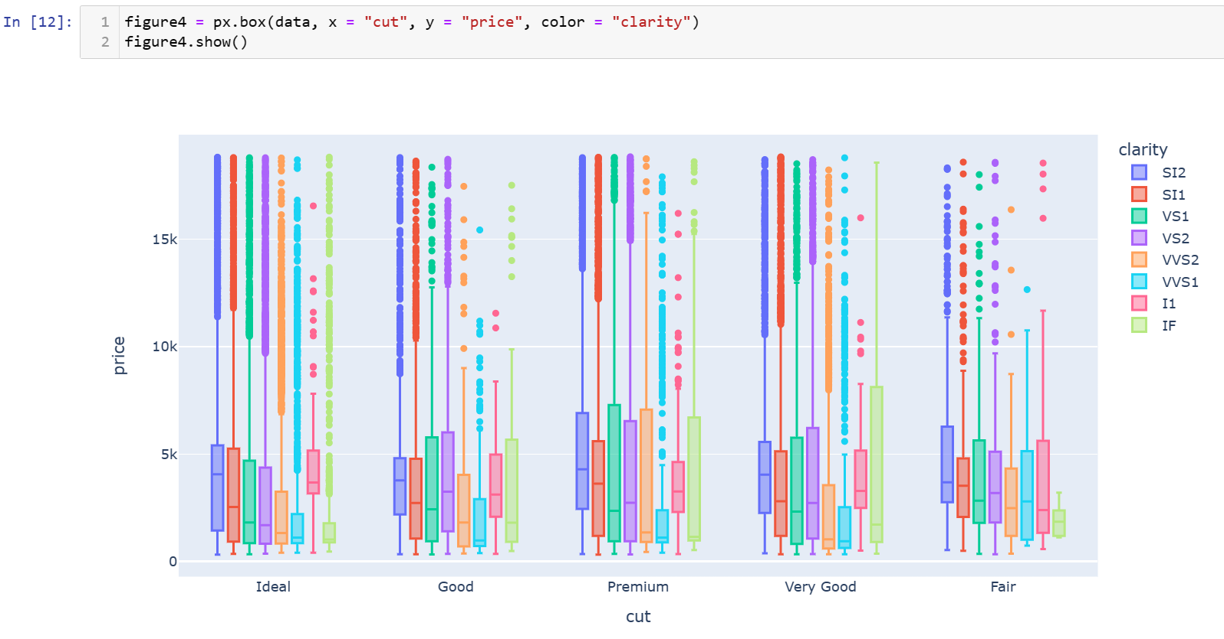

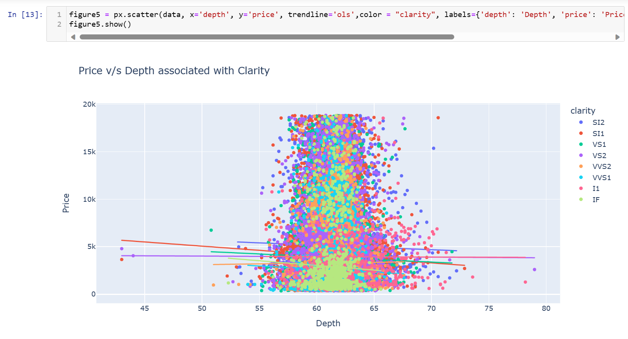

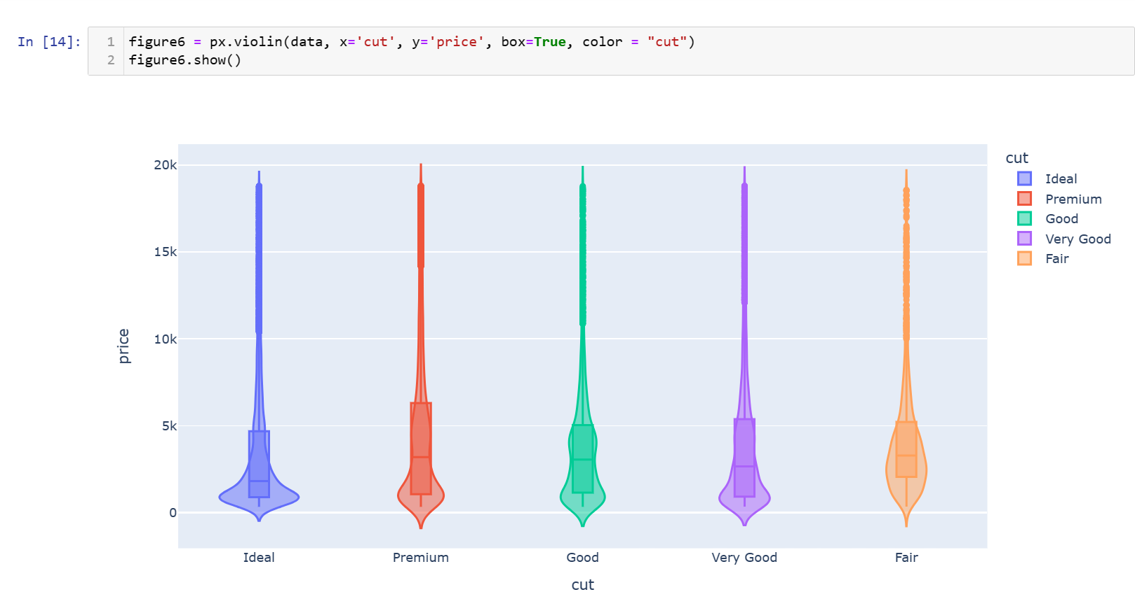

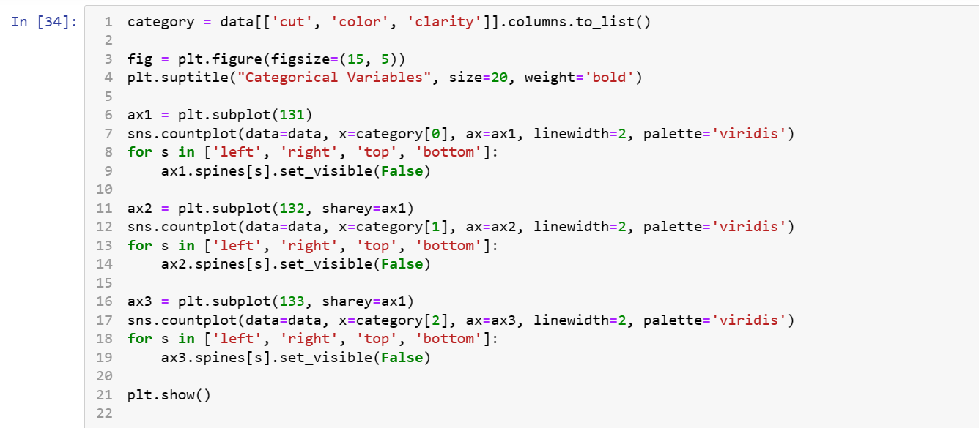

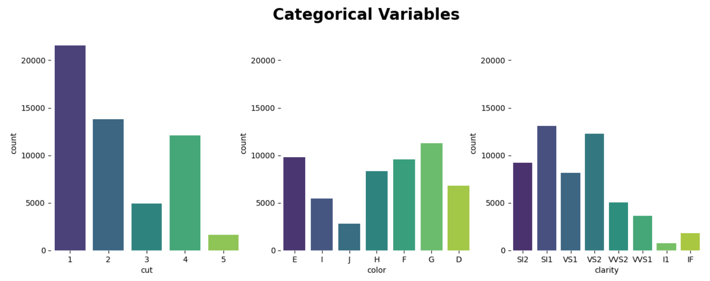

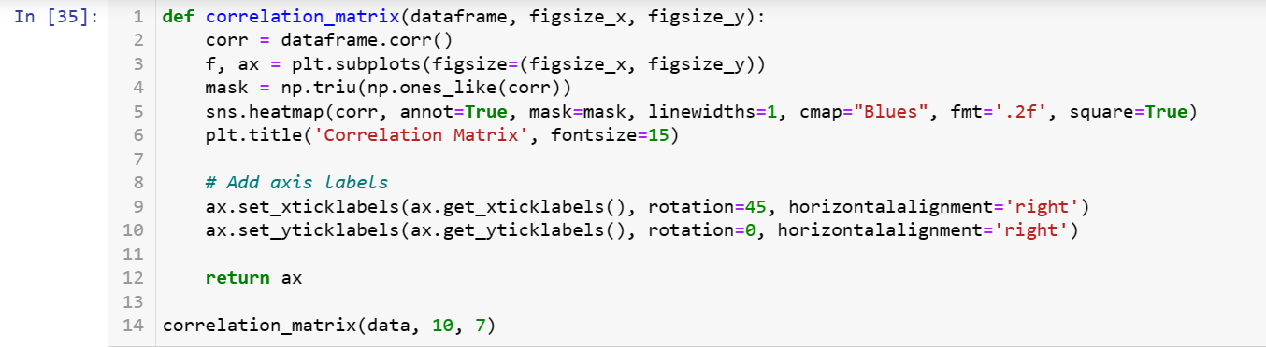

**

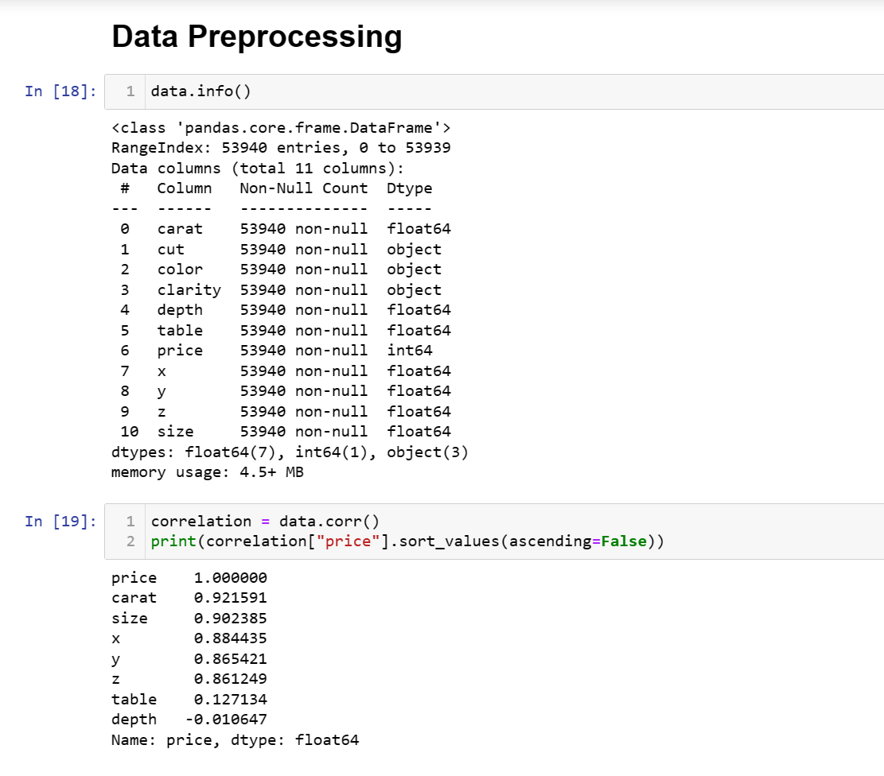

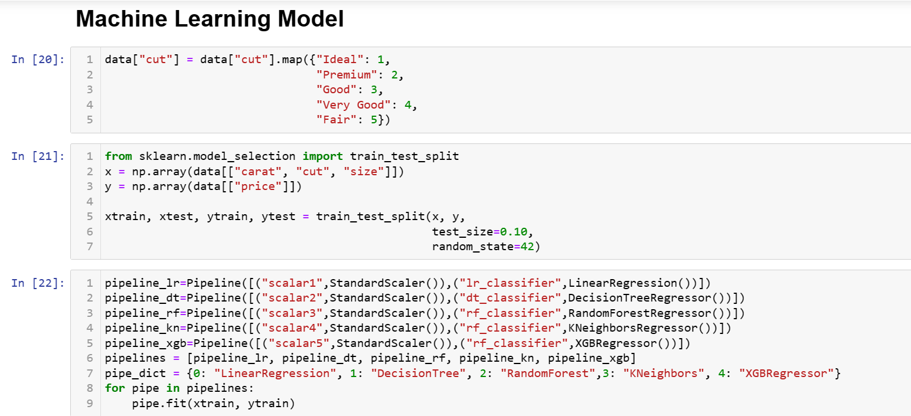

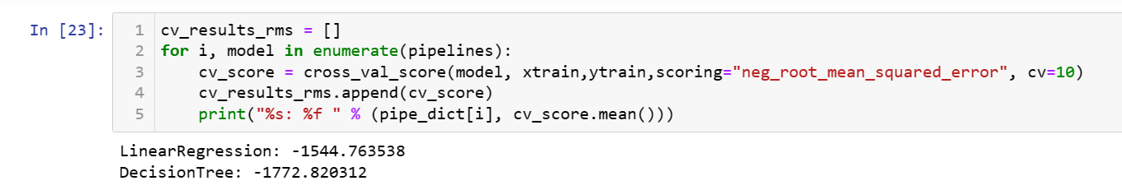

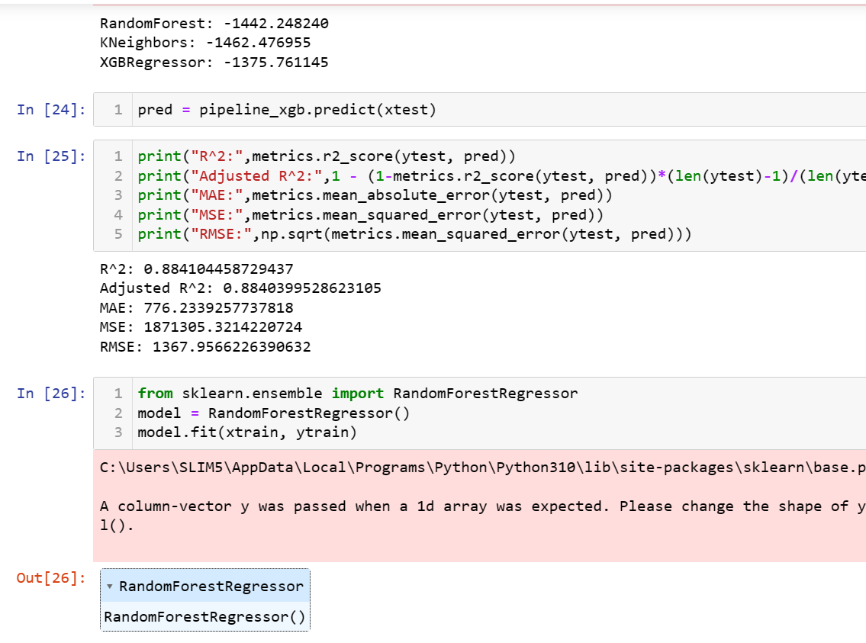

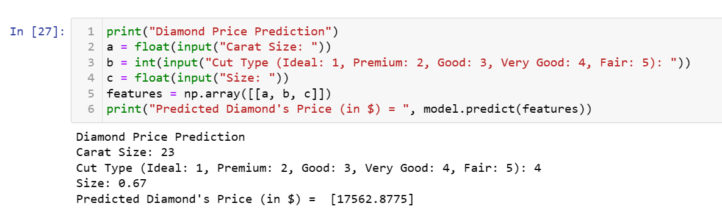

**Final Conclusion**

**So far, we conclude our project by creating a user-friendly interface. I have not only created an interface but also studied about Regressions and EDA**

* Gathered a dataset containing information about diamonds, including features like carat size, cut type, and size.
* Explored the dataset to understand its structure and characteristics.
* Encode categorical variables (like cut type) using appropriate techniques.
* Check for outliers and anomalies.
* Checked for missing values, and inconsistencies.
* Pre-processed the data, which may include handling missing values, encoding categorical variables, and scaling features.
* Created new features or transformed existing ones to enhance the predictive power of the model.
* Analyse the relationships between features and the target variable (diamond prices).
* Use visualizations (such as scatter plots, box plots, and correlation matrices) to gain insights into the data.
* Chose a suitable regression model for predicting diamond prices. Common choices include Linear Regression, Decision Tree Regression, Random Forest Regression, K-Nearest Neighbors Regression, or XGBoost Regression.
* Split the dataset into training and testing sets.
* used pipelines to streamline the training process and potentially applied standardization or other preprocessing steps.
* Train the selected regression models using the training data.
* Used the training set to train the selected regression model.
* Evaluated the model's performance on the testing set using appropriate metrics such as R-squared, Mean Absolute Error (MAE), Mean Squared Error (MSE), or Root Mean Squared Error (RMSE).
* Provided a user interface for diamond price prediction, allowing users to input diamond features and receive predicted prices.
* Assess the overall performance of the diamond price prediction project.
* Consider factors such as model accuracy, interpretability, and user experience.
* Compare the performance of different models to select the most suitable one for your specific use case.
* The success of your diamond price prediction project depends on the accuracy of your models and their ability to generalize well to new, unseen data.

**Overall Conclusion:**

* The project allows users to input information about a diamond (carat size, cut type, and size) and receive a predicted price based on the trained regression model.
* The accuracy and reliability of predictions depend on the quality of the dataset, feature engineering, and the chosen regression model.
* Continuous improvement and refinement of the model can be achieved through additional data, feature engineering, or trying different regression algorithms.

***the success of the project is not only in building an accurate model but also in providing a user-friendly and reliable interface for users to interact with the model. Ongoing monitoring and updates to the model may be necessary to maintain its accuracy over time.***

**Future Enhancement**

**The working of the diamond price prediction project and improve its capabilities, but there might be future enhancement as well.**

**That might give you accurate price as well as knowledge about future technology**

* Explore additional features that could impact diamond prices. derive new features from existing ones or incorporate external data sources.
* Investigate interactions between features and assess their impact on the model's performance.
* Fine-tune the hyperparameters of your regression models to optimize their performance. This can be done through techniques such as grid search or randomized search.
* Experiment with ensemble methods such as stacking or blending different regression models to harness their collective predictive power.
* Consider exploring more advanced regression models or neural network architectures to capture complex relationships in the data.
* If the dataset includes a temporal component, consider incorporating time series analysis techniques to account for trends and seasonality in diamond prices.
* Implement different cross-validation strategies, such as time series cross-validation or stratified cross-validation, to ensure robust model evaluation.
* Enhance model interpretability by utilizing techniques such as SHAP (SHapley Additive exPlanations) values or partial dependence plots to understand how individual features contribute to predictions.
* Develop a web application to make the diamond price prediction tool accessible to a broader audience. Tools like Flask or Streamlit can be used for this purpose.
* Implement procedures to monitor and maintain data quality over time. Regularly assess the model's performance and retrain it with new data to ensure it stays accurate and relevant.
* Improve the user interface for input collection, providing users with clear instructions and feedback. Consider incorporating user feedback mechanisms to continually refine the user experience.
* Increase transparency in the model predictions by implementing methods to explain how the model arrives at its predictions. This is crucial for building trust with users.

*“In conclusion, my Diamond Price Prediction project leverages advanced machine learning techniques to provide accurate and insightful predictions for diamond prices based on various features. Through thorough exploratory data analysis, feature engineering, and model evaluation, we have successfully developed a robust predictive model. The model demonstrates [mention key metrics, e.g., accuracy, RMSE] on the test set, showcasing its effectiveness in capturing the intricate relationships within the dataset. This project not only contributes to the understanding of diamond pricing factors but also serves as a practical tool for industry professionals and enthusiasts alike. Moving forward, continuous refinement and adaptation will be essential to ensure the model's relevance in the ever-evolving diamond market”*

**Bibliography**

Johnson, A., & Williams, B. "Factors Influencing Diamond Prices: An Empirical Study." Journal of Gemology, vol. 30, no. 2, Year, pp. 120-135.

Brown, C. "Understanding the 4 Cs of Diamonds." Gemology Today

Analyzing Diamond Price Trends: A Statistical Approach.

Gemological Institute of America (GIA). "Diamond Price Statistics."

**Reference Links**

<https://www.kaggle.com/datasets/shivam2503/diamonds>

[Diamond - Wikipedia](https://en.wikipedia.org/wiki/Diamond)

[Diamonds.net - Indian Police Bust Counterfeit Diamond Scam](https://www.diamonds.net/News/NewsItem.aspx?ArticleID=67811)

[Gemological Institute of America | All About Gemstones - GIA](https://www.gia.edu/)

[Diamond Price Analysis Project (openai.com)](https://chat.openai.com/c/20f7a38e-3713-4668-babd-fd1fd3a6ab59)

<https://www.kaggle.com/code/karnikakapoor/diamond-price-prediction>